**2-STEP ANN PREDICTIONS**

**900 MHz, 17mm (0.05 lambda)**

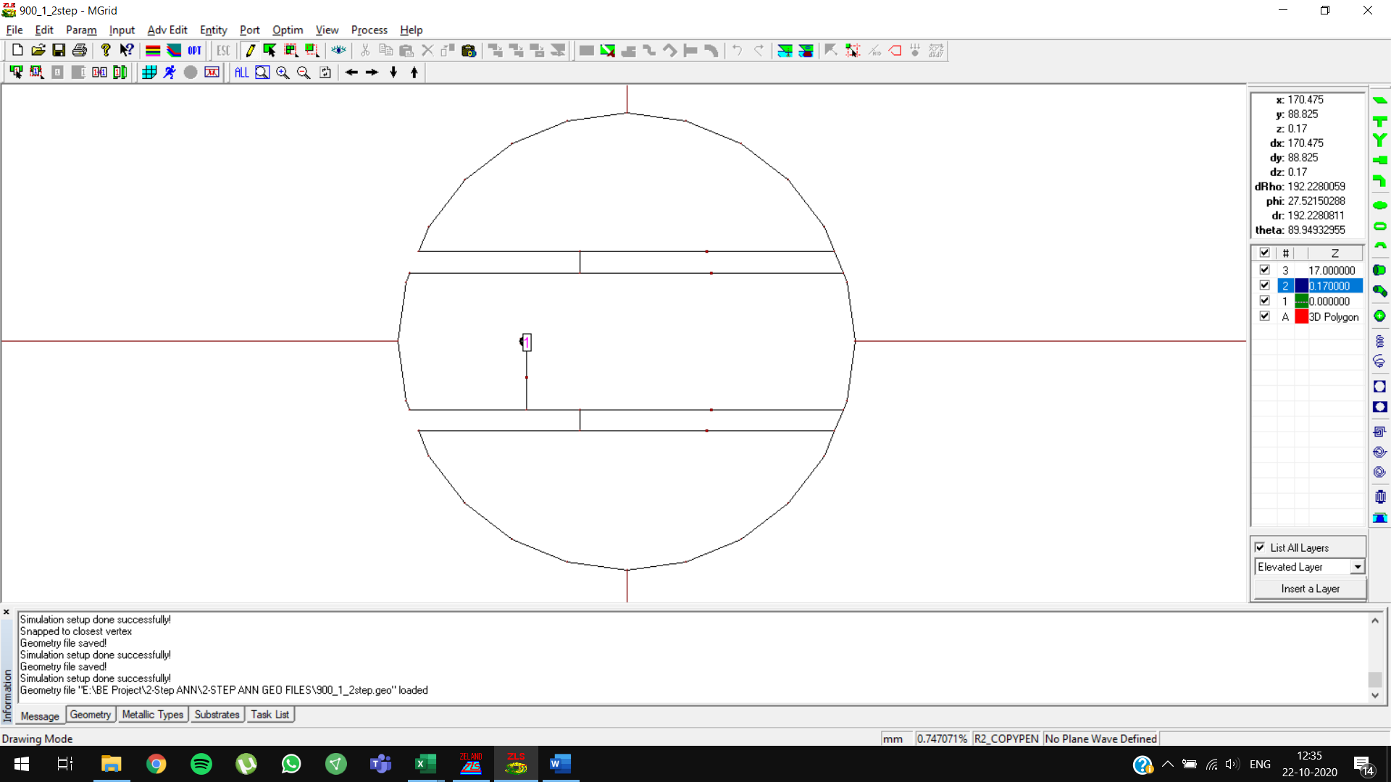

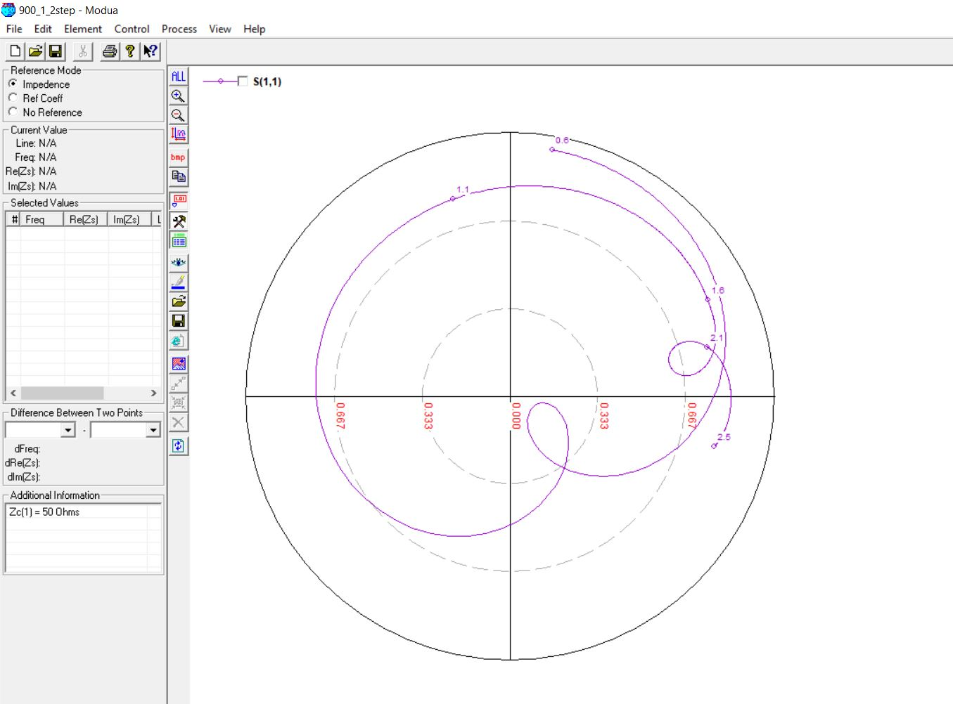

**900 MHz, 22mm (0.07 lambda)**

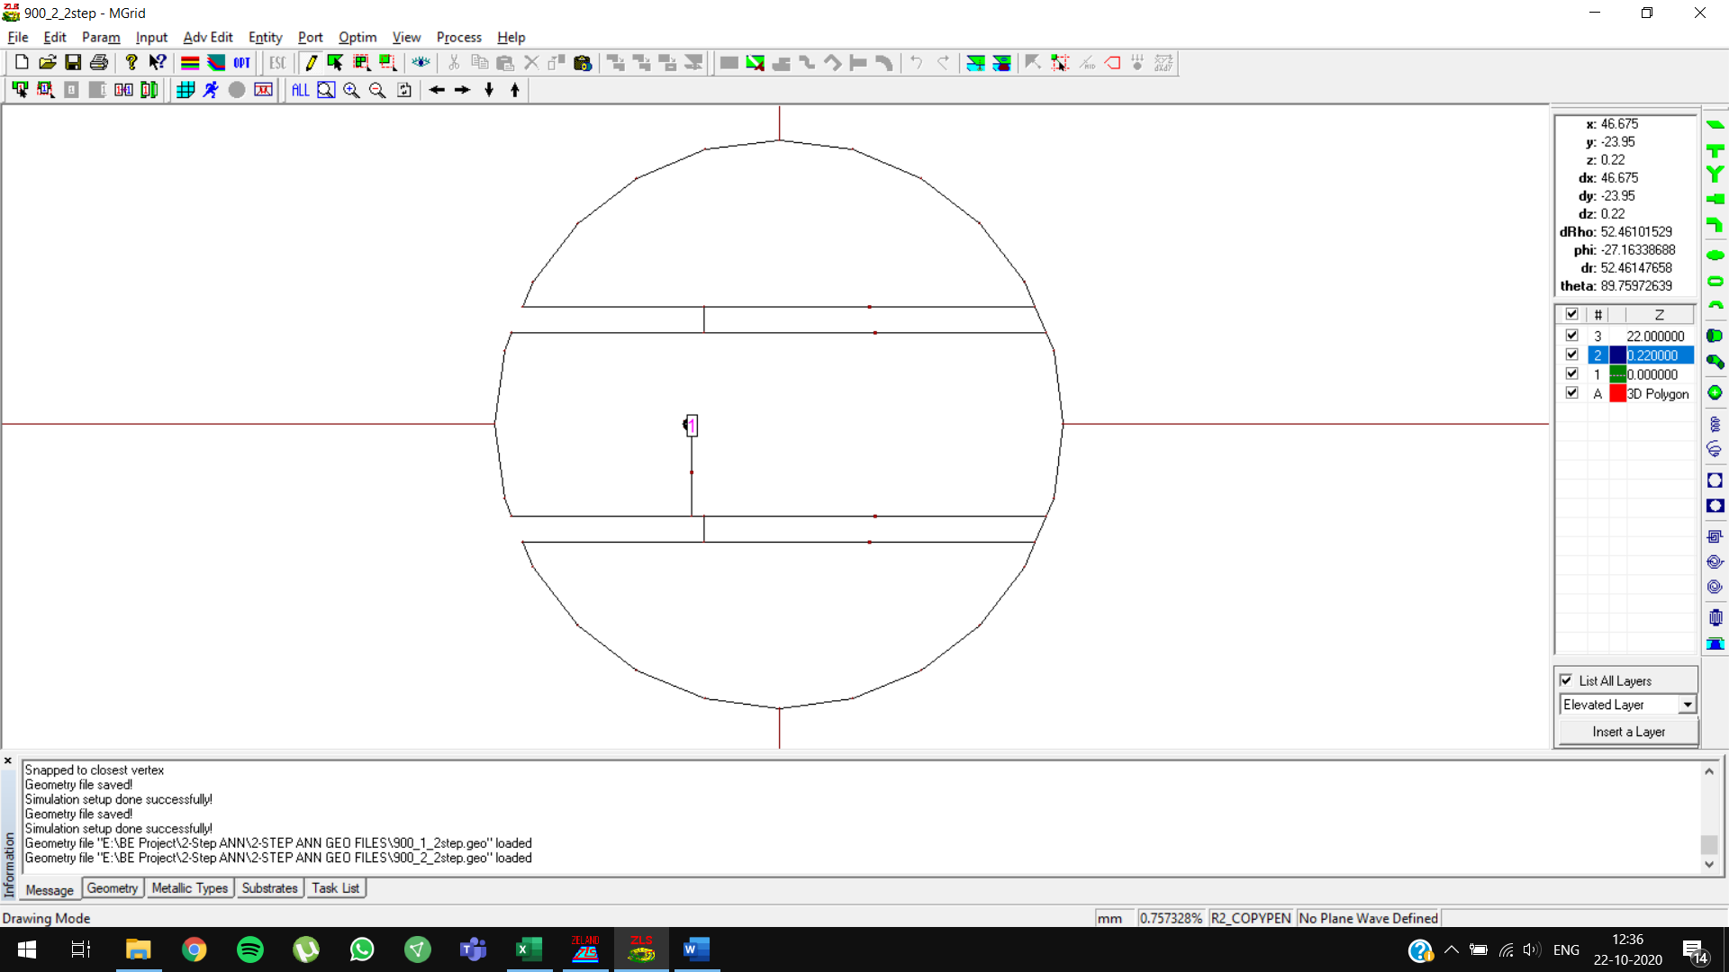

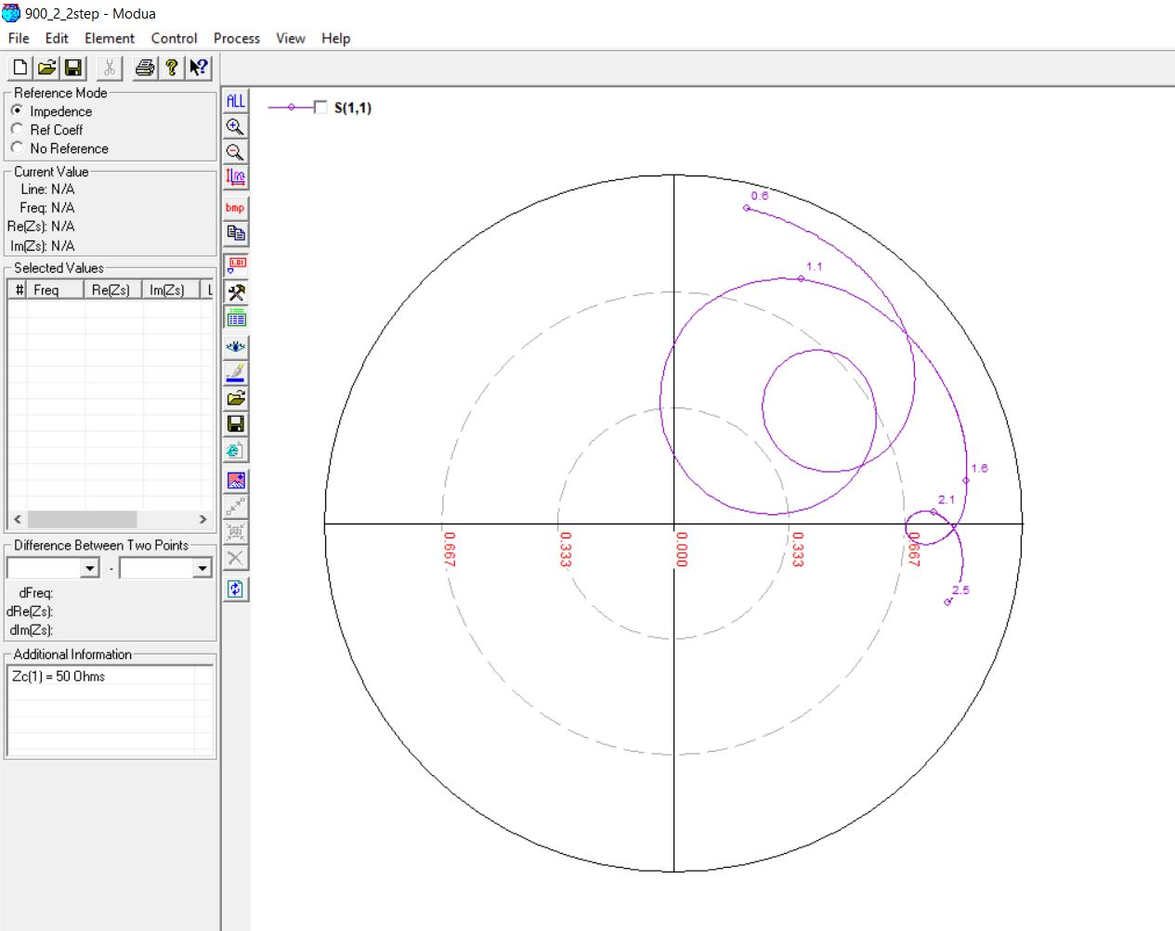

**1500 MHz, 11mm (0.05 lambda)**

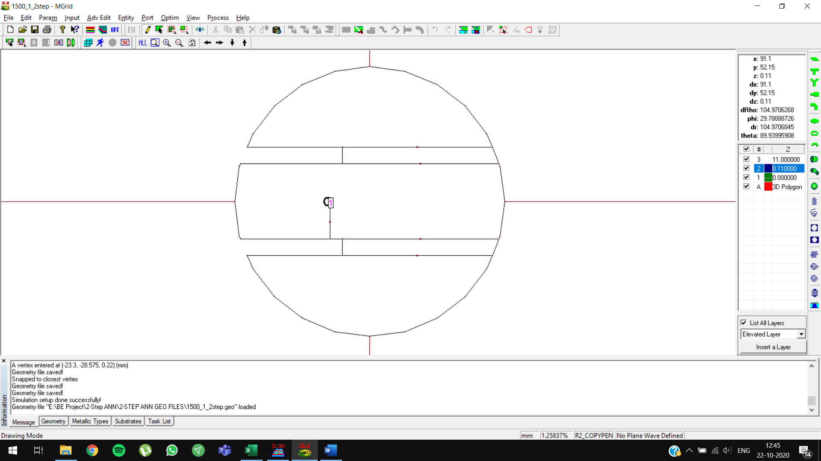

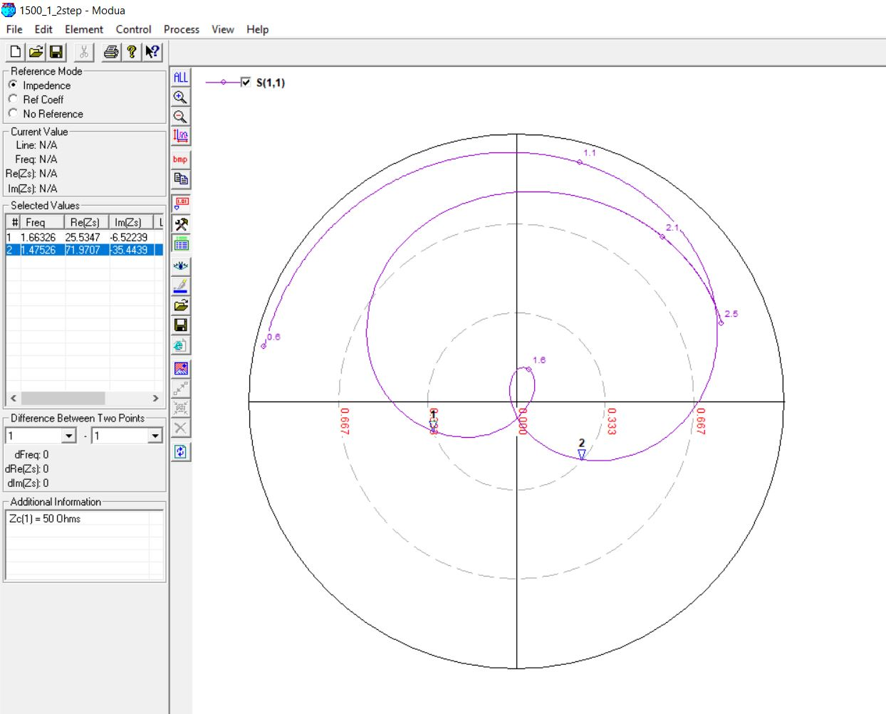

**1500 MHz, 14mm (0.07 lambda)**

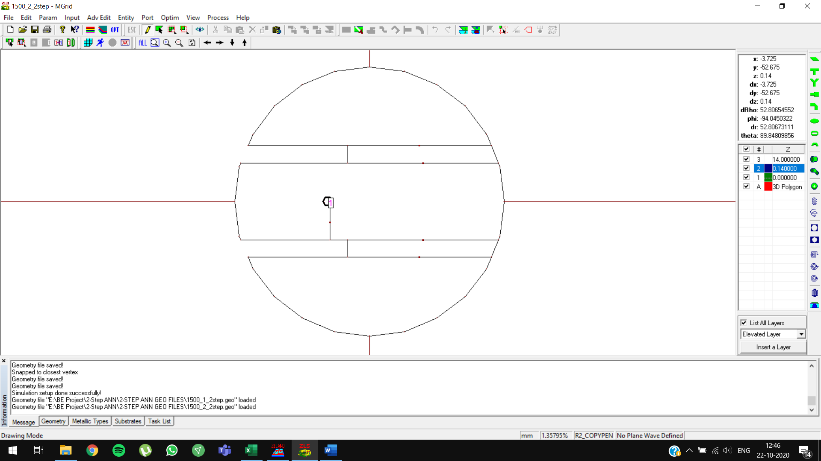

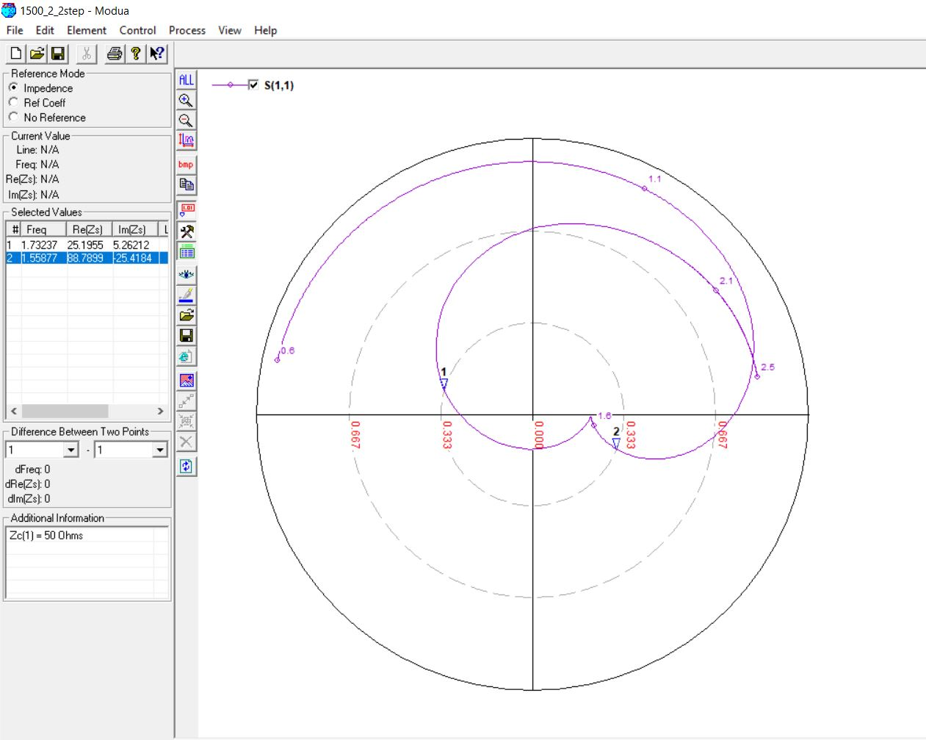

**1500 MHz, 14mm (0.07 lambda) OPTIMIZED**

Initial predictions: feed position = **-14.4858**, slot length = **38.7781 mm**

Optimized predictions: feed position = **-13.4858**, slot length = **37.7781 mm**

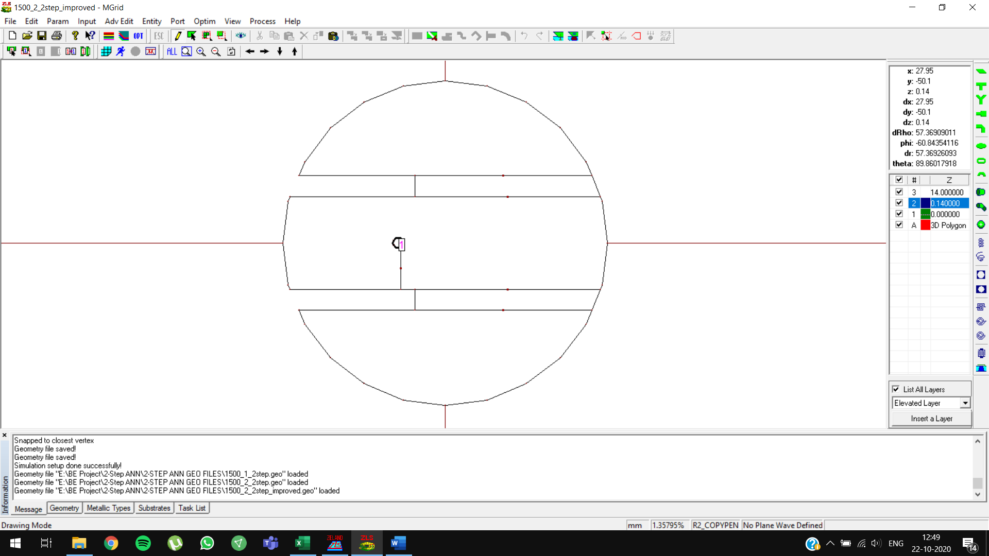

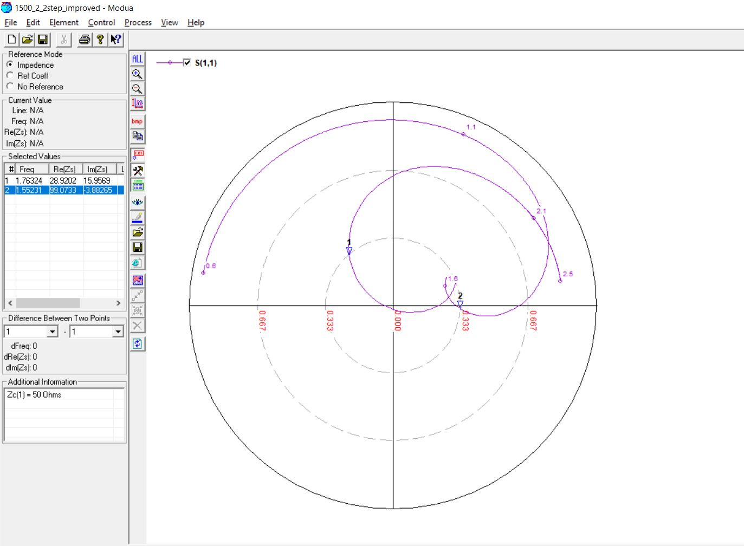

**2100 MHz, 8mm (0.05 lambda)**

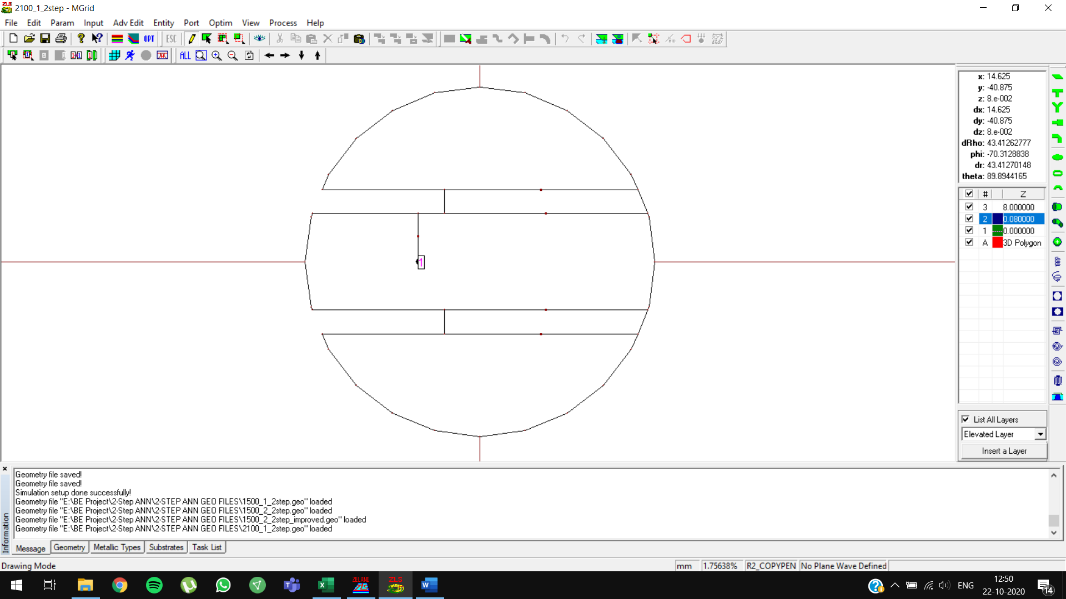

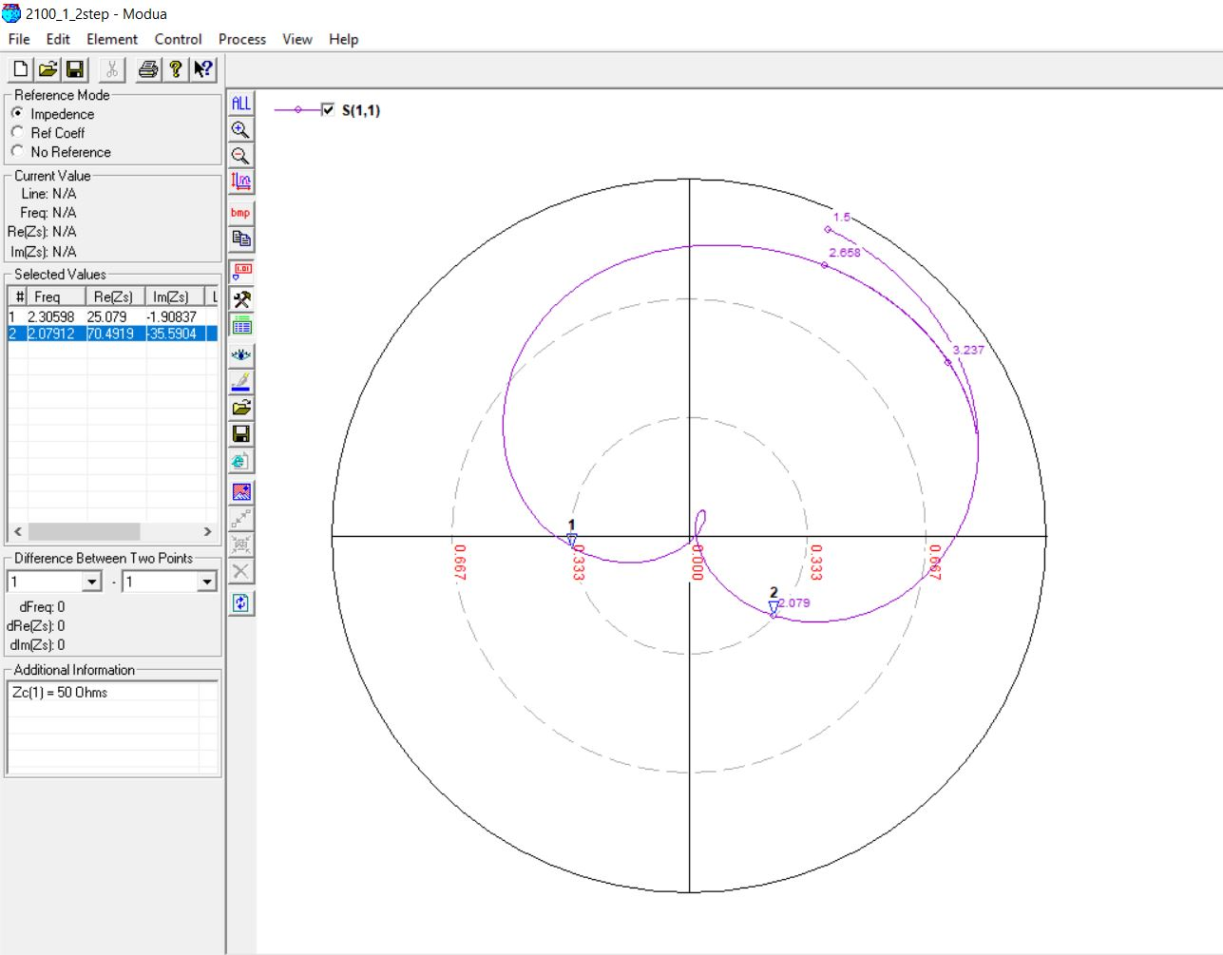

**2100 MHz, 10mm (0.07 lambda)**

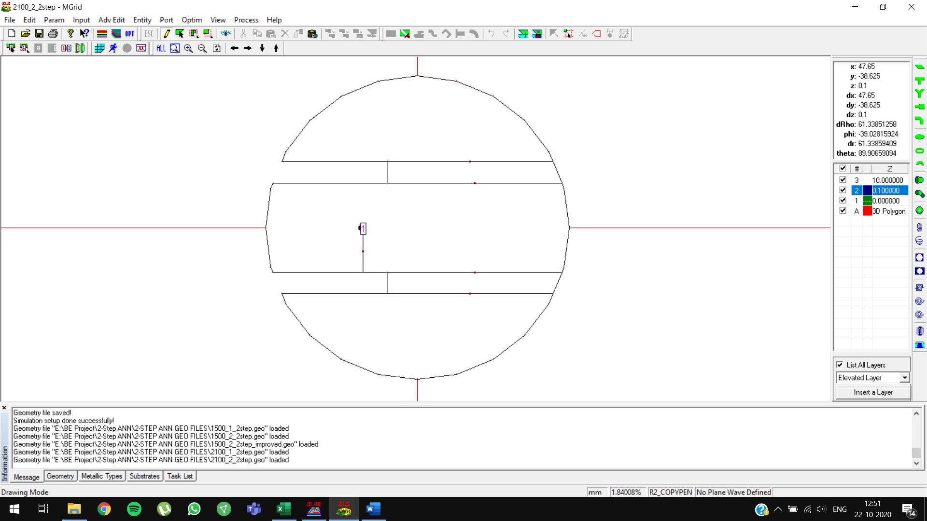

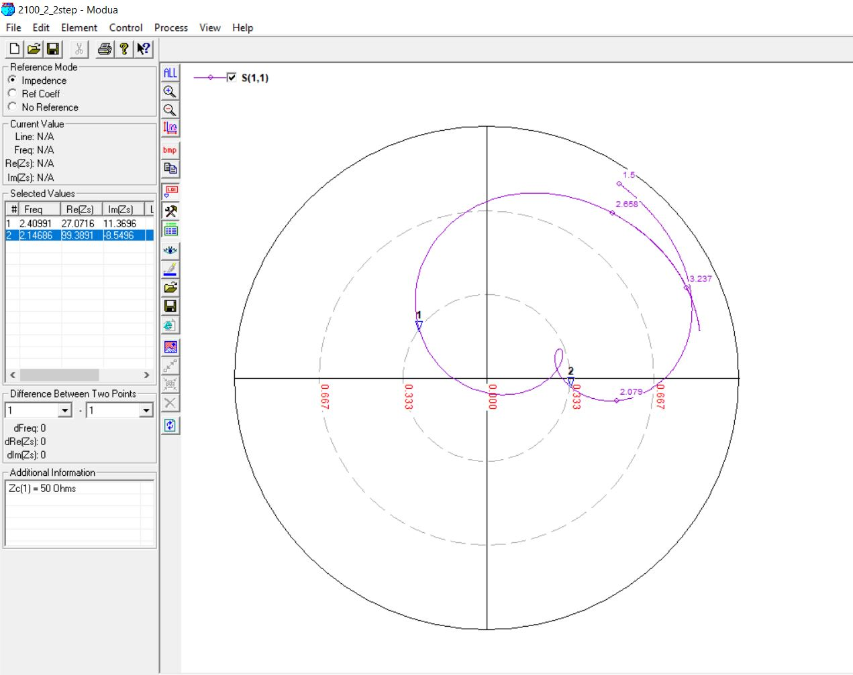

**2700 MHz, 6mm (0.05 lambda)**

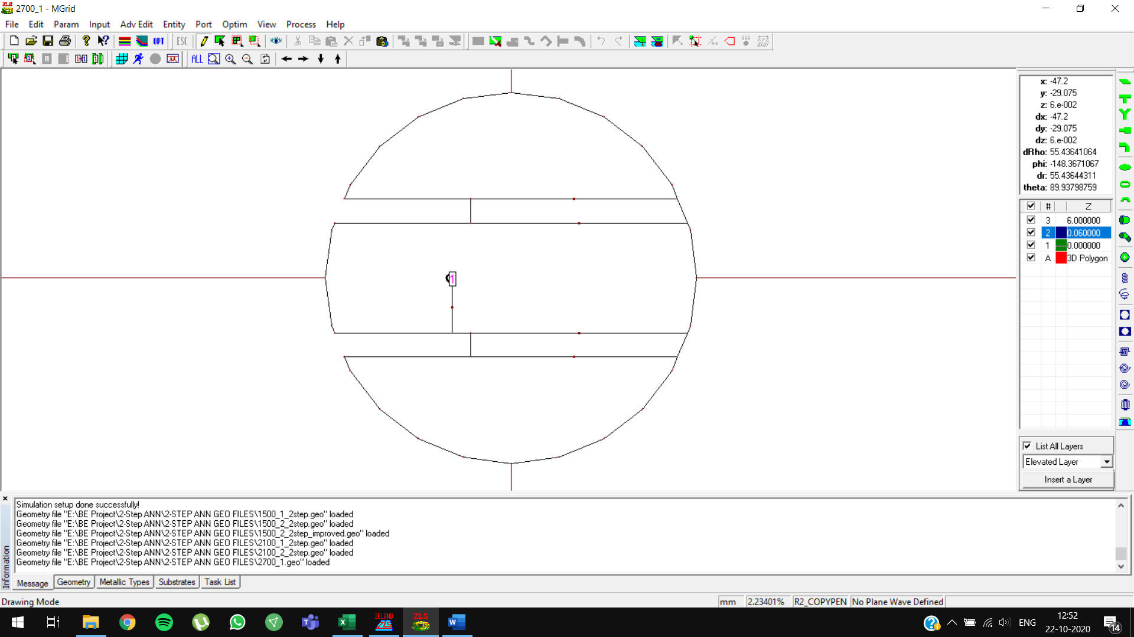

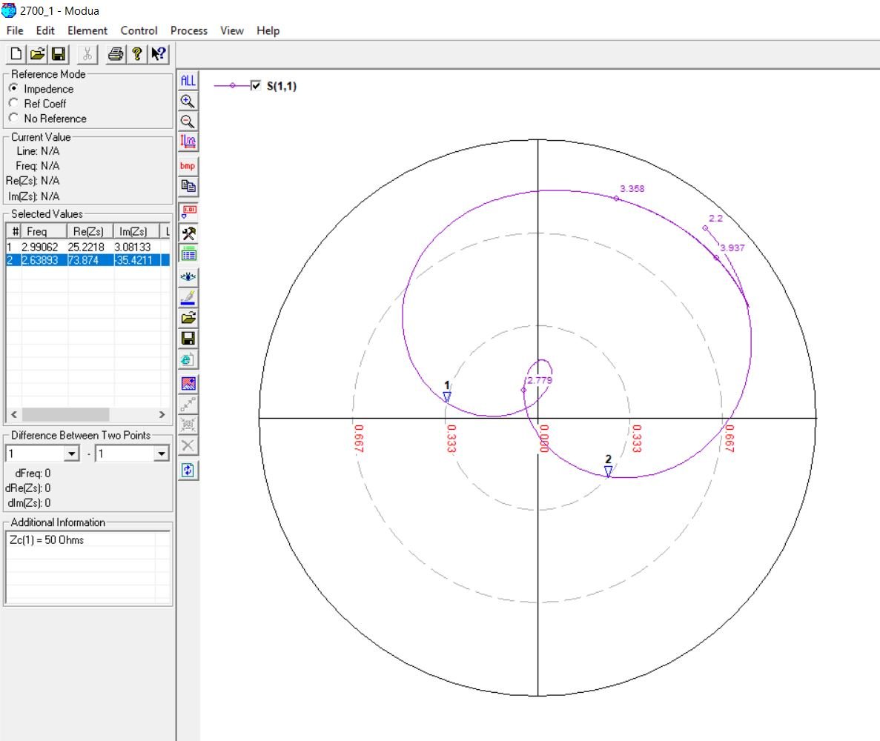

**2700 MHz, 7mm (0.07 lambda)**

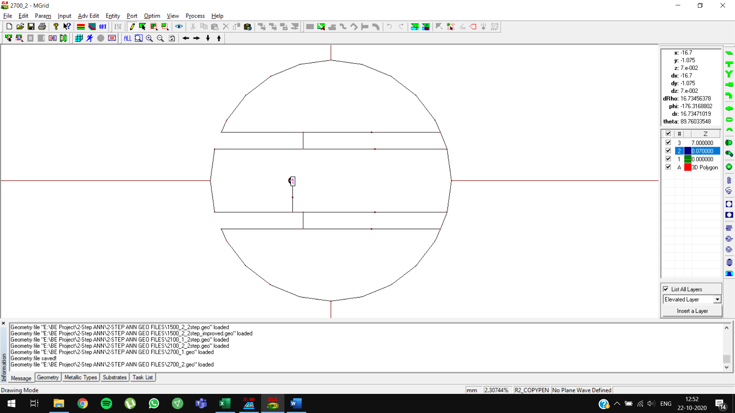

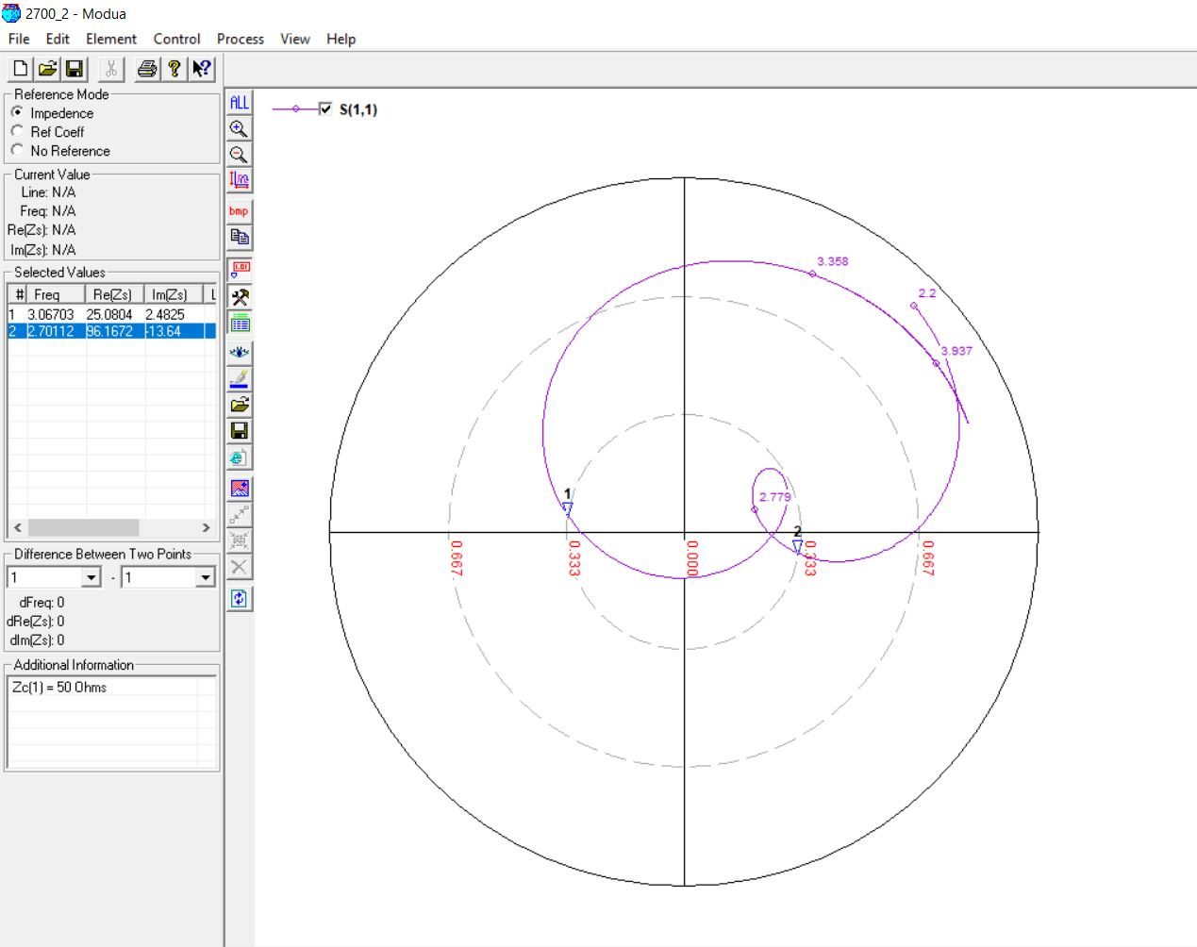

**3300 MHz, 5mm (0.05 lambda)**

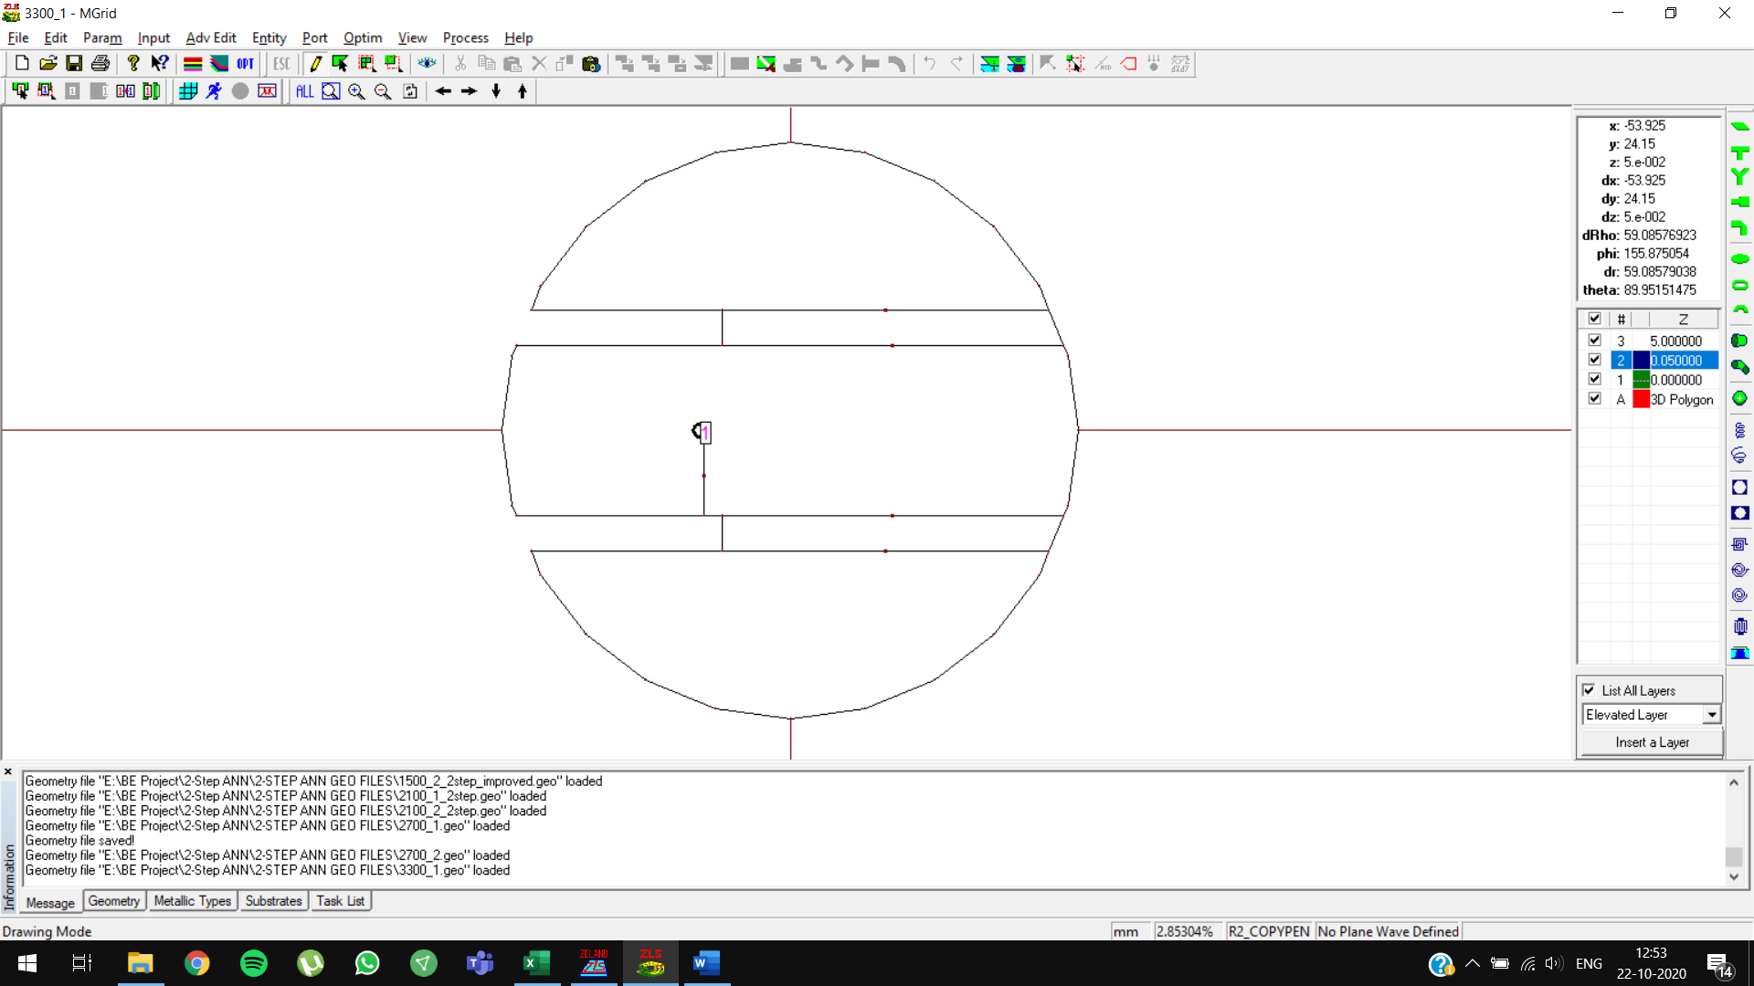

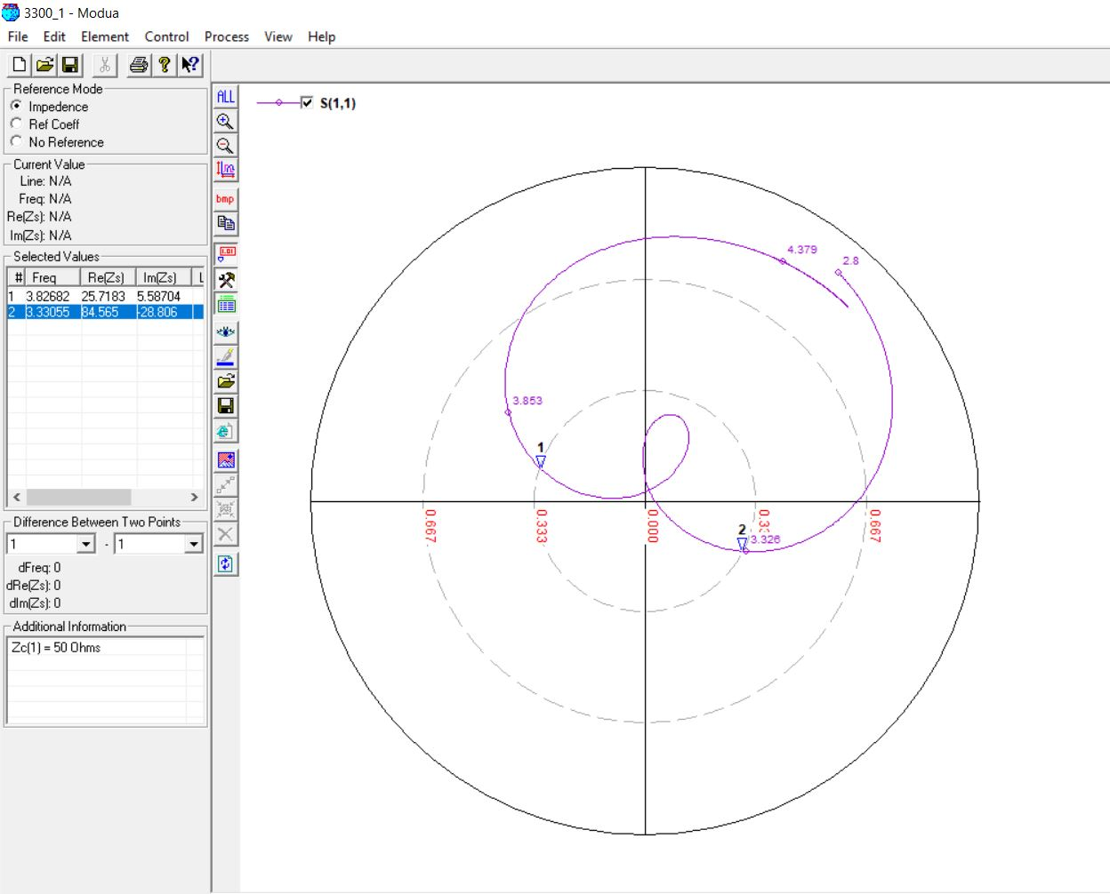

**3300 MHz, 6mm (0.07 lambda)**

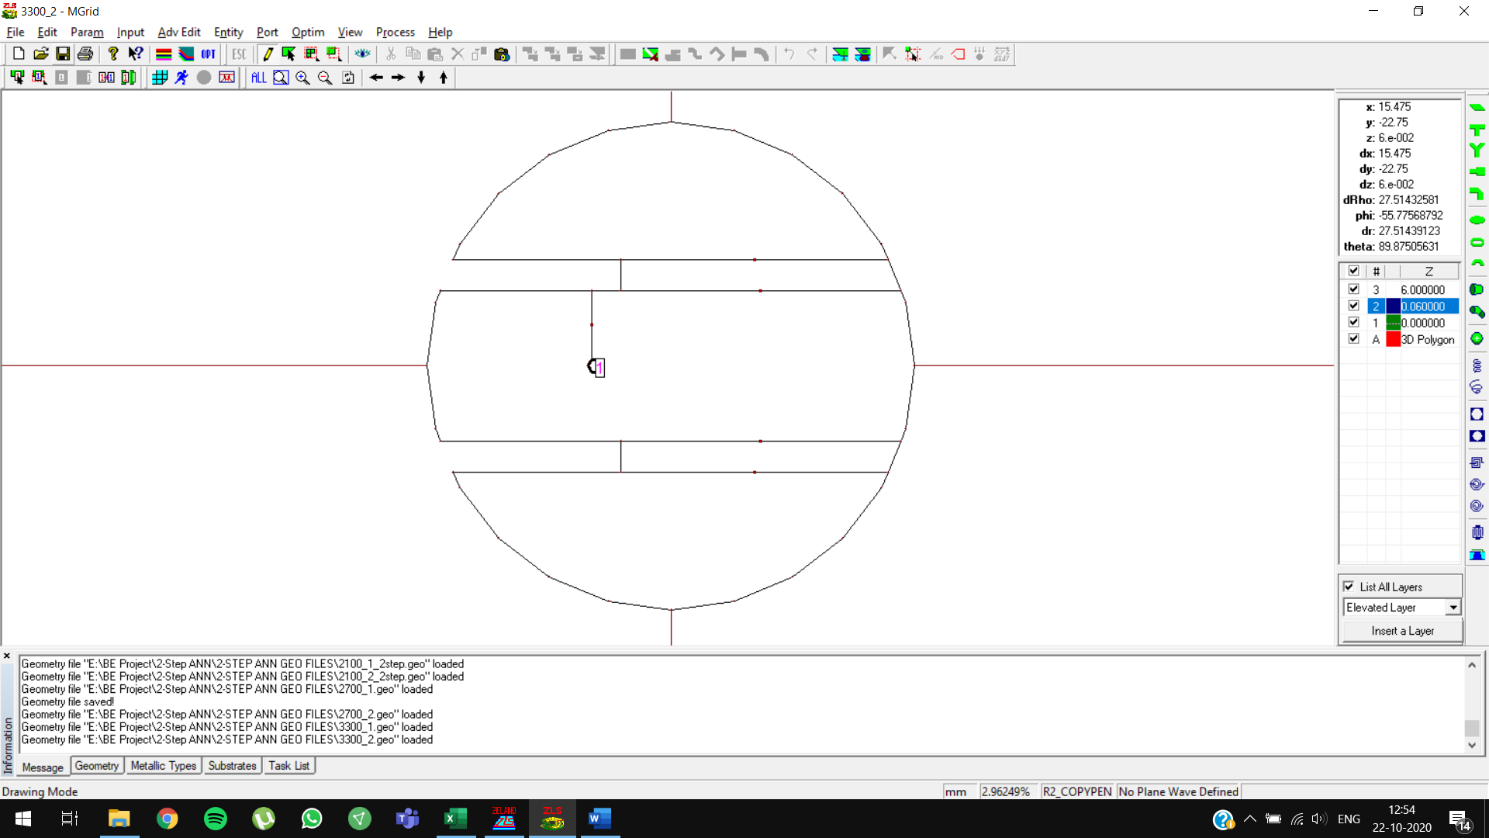

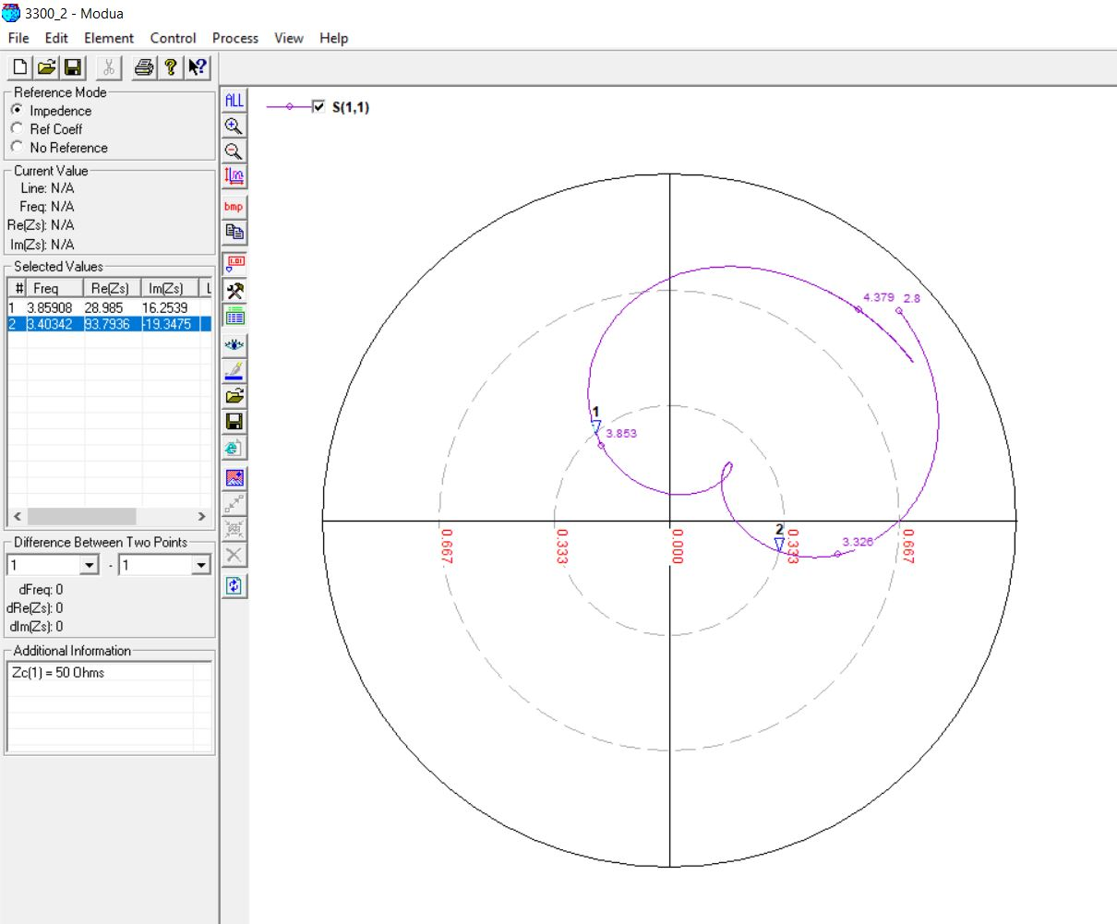

**3900 MHz, 4mm (0.05 lambda)**

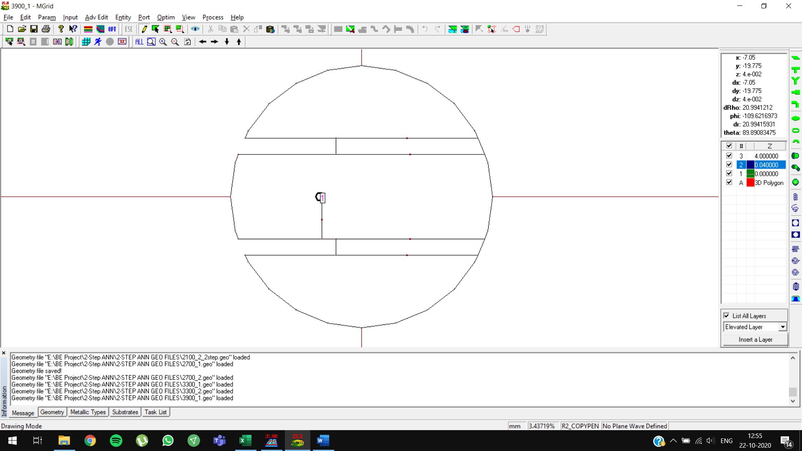

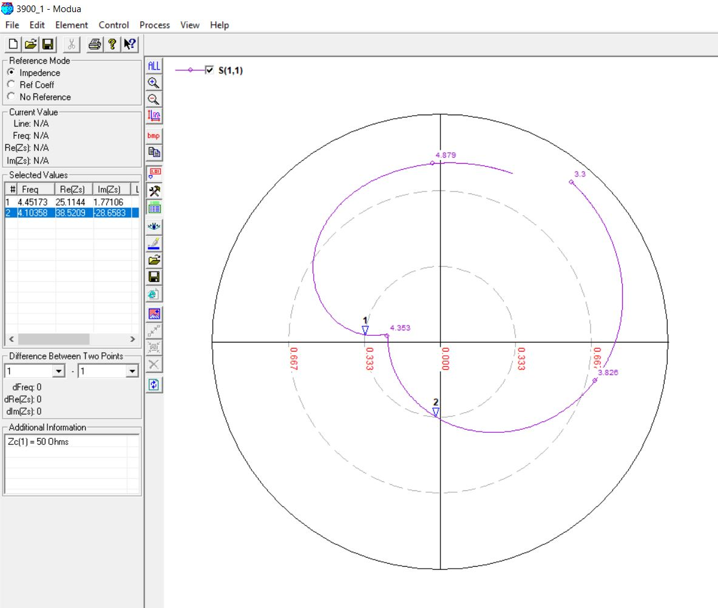

**3900 MHz, 4mm (0.05 lambda) OPTIMIZED**

Initial predictions: slot length = **14.7247 mm**

Optimized predictions: slot length = **13.7287 mm**

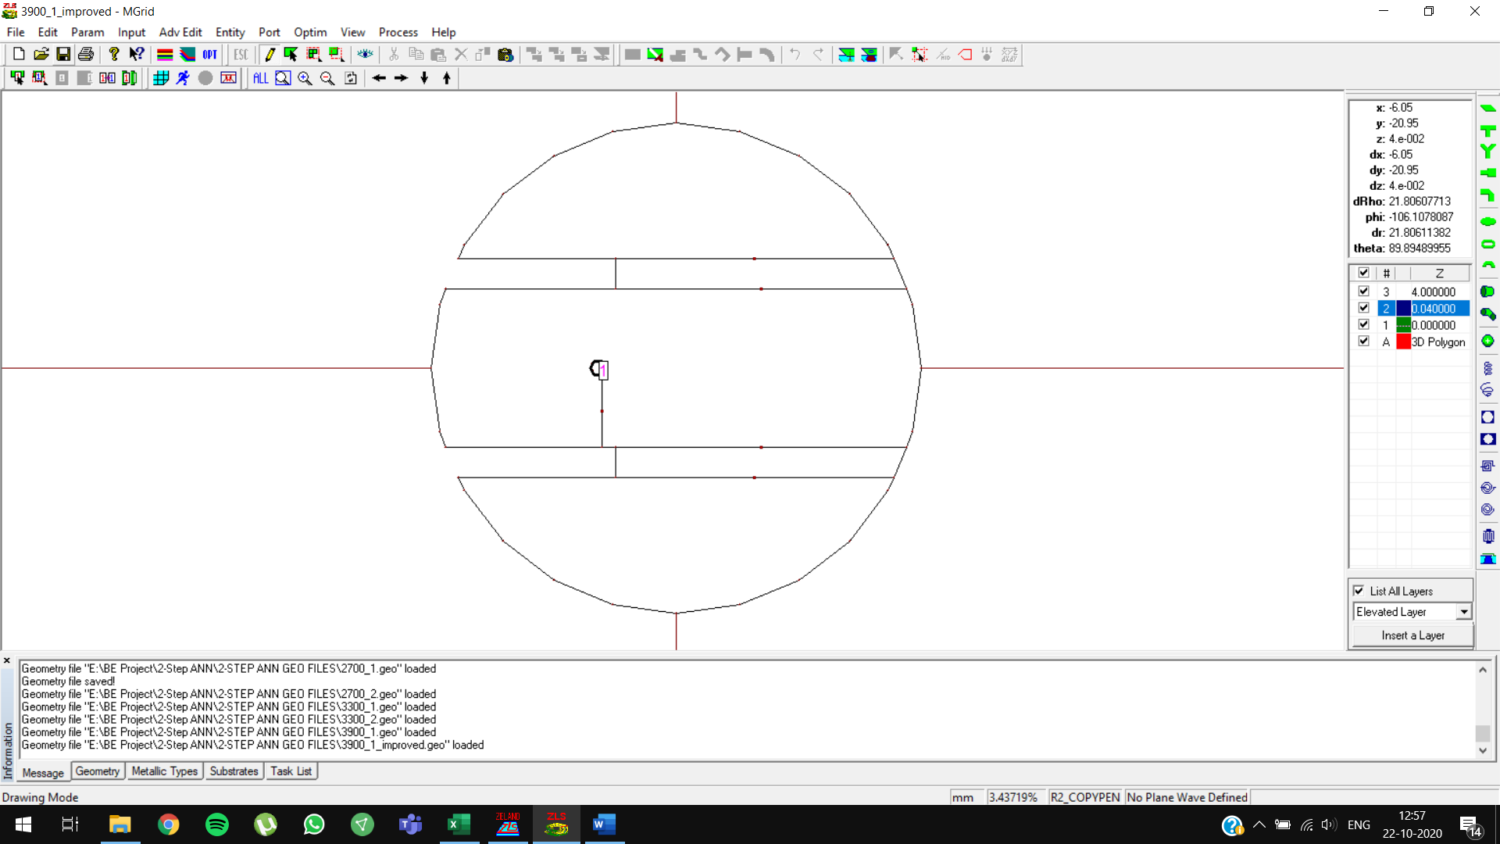

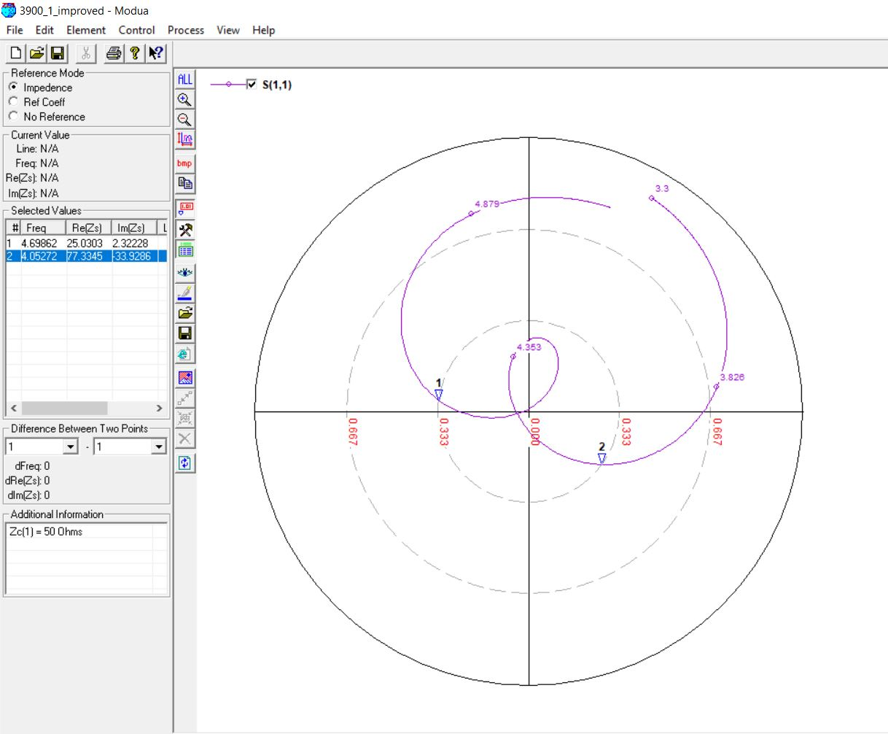

**3900 MHz, 5mm (0.07 lambda)**

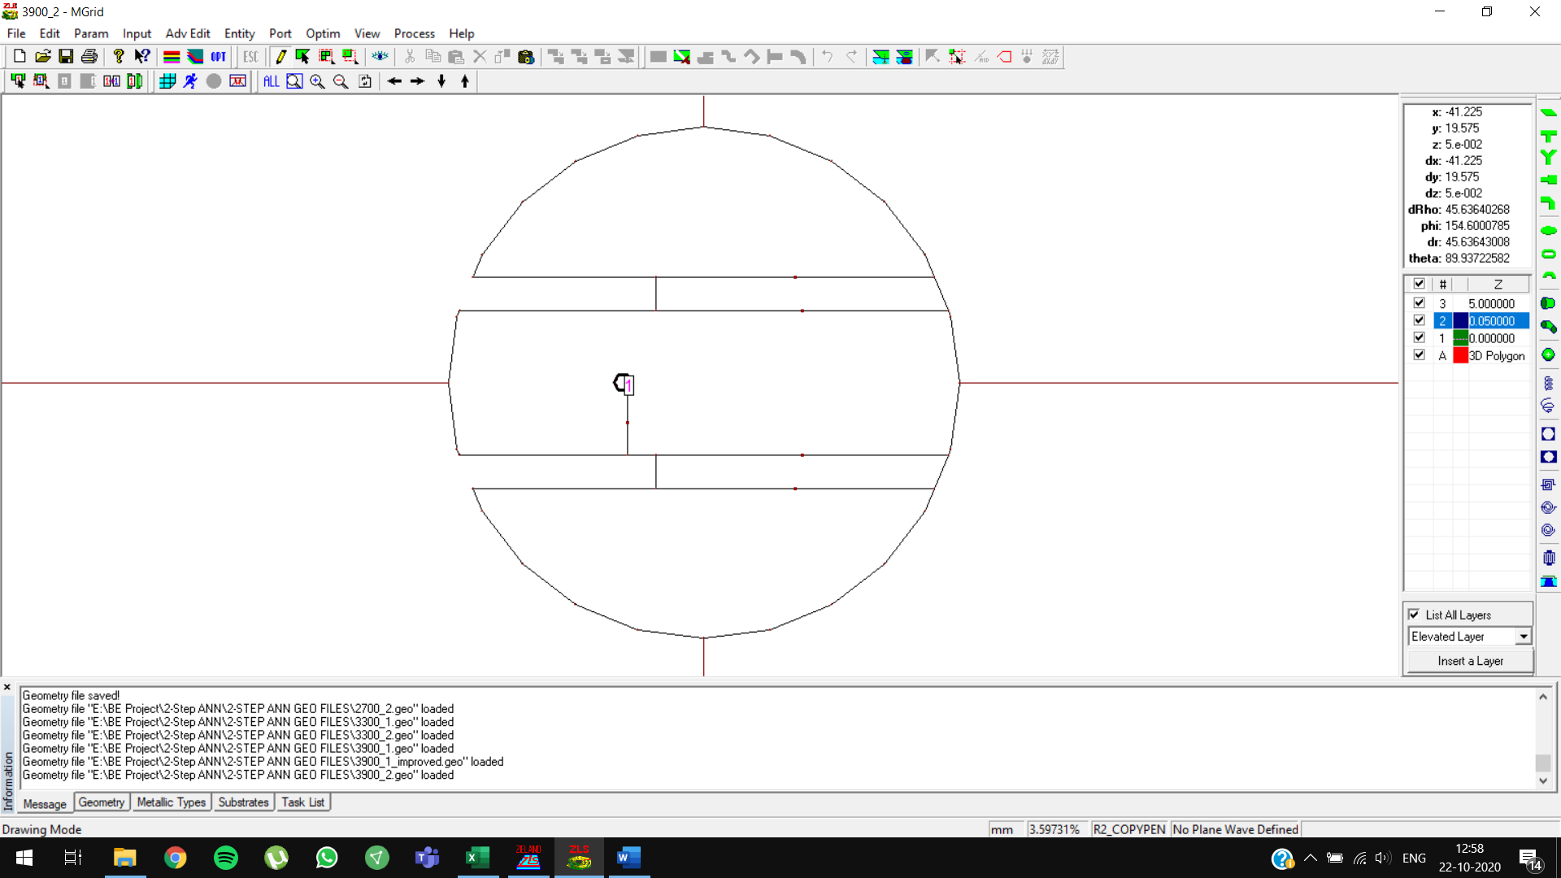

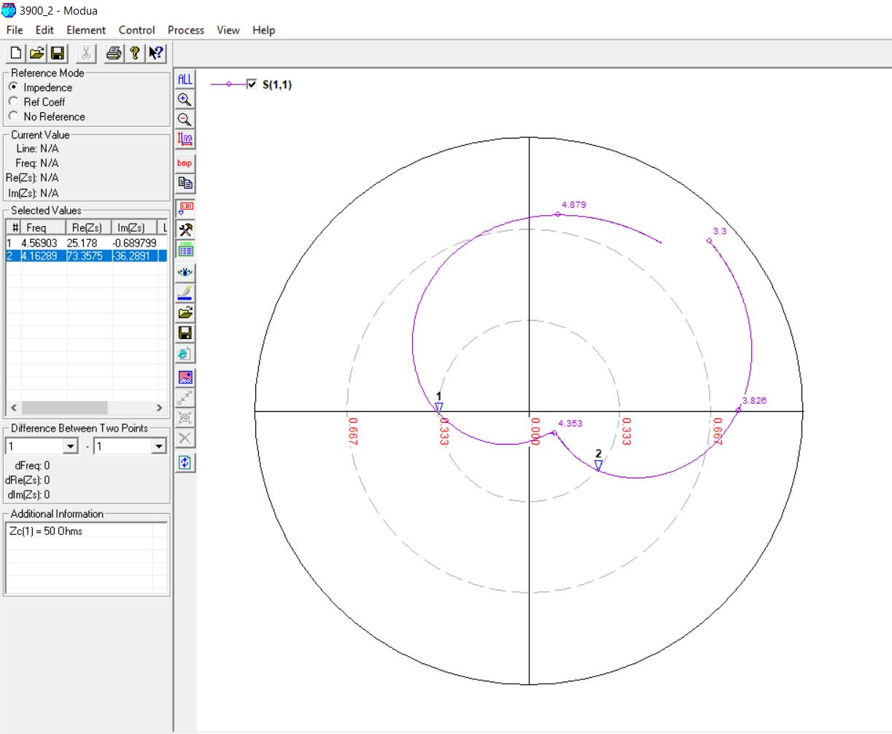

**3900 MHz, 5mm (0.07 lambda) OPTIMIZED**

Initial predictions: slot length = **14.2496 mm**

Optimized predictions: slot length = **13.4250 mm**

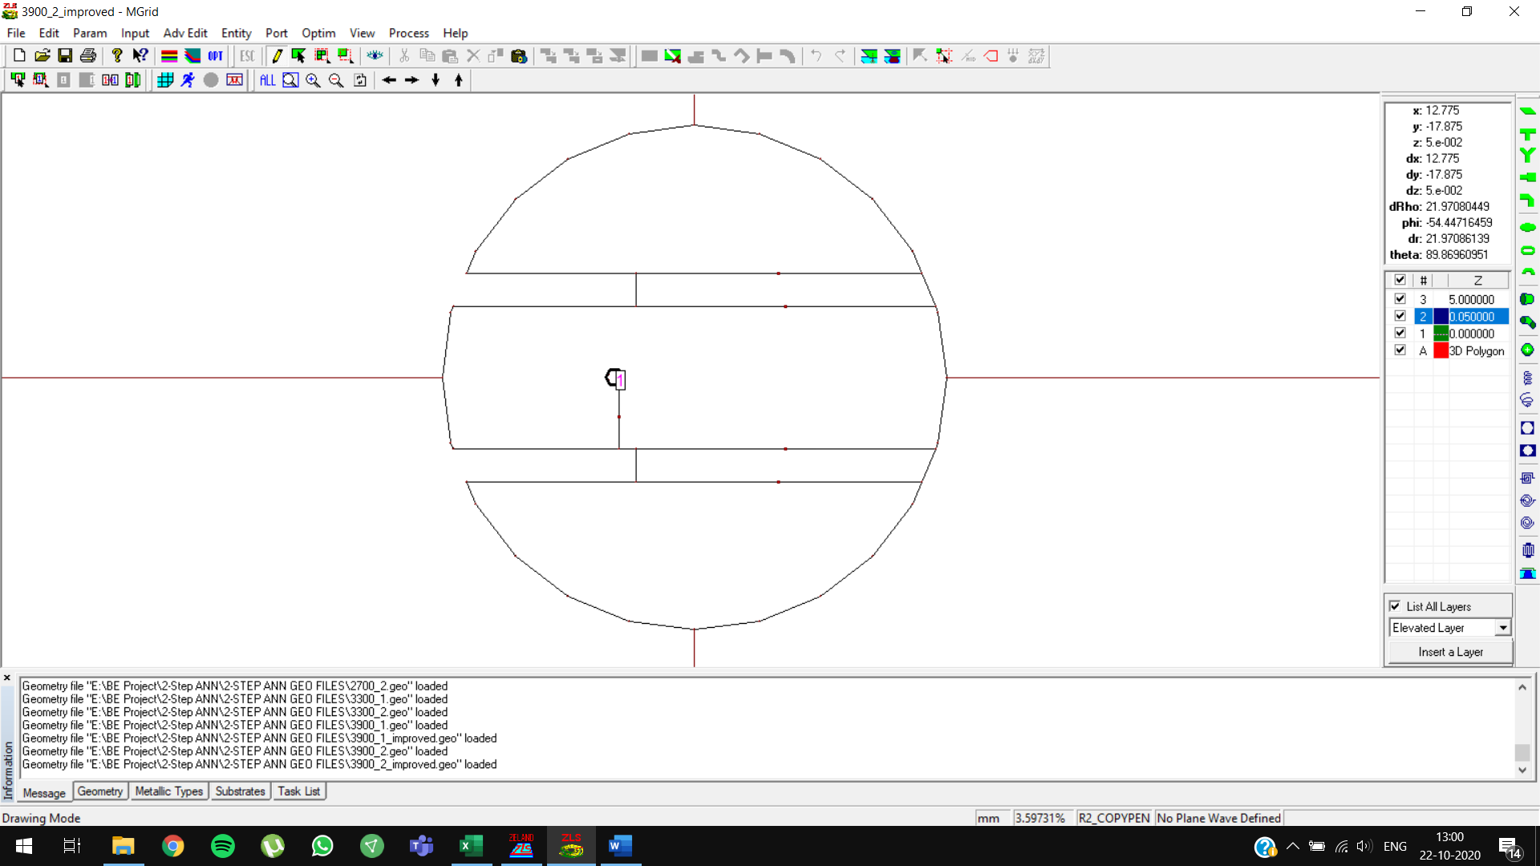

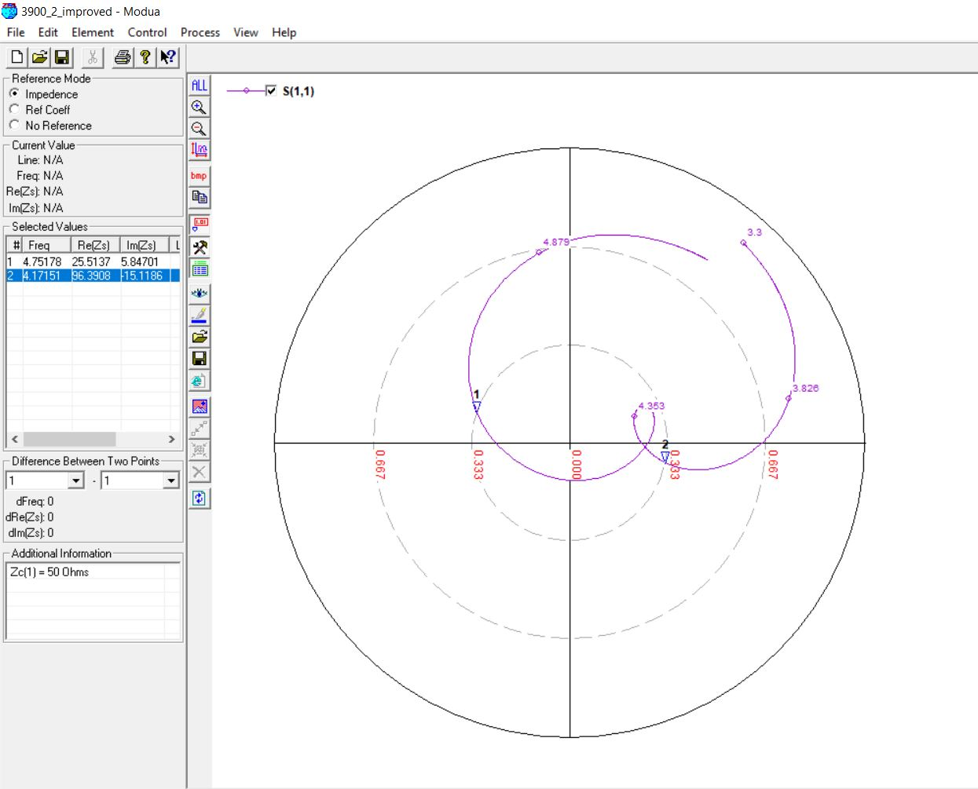

**4300 MHz, 4mm (0.05 lambda)**

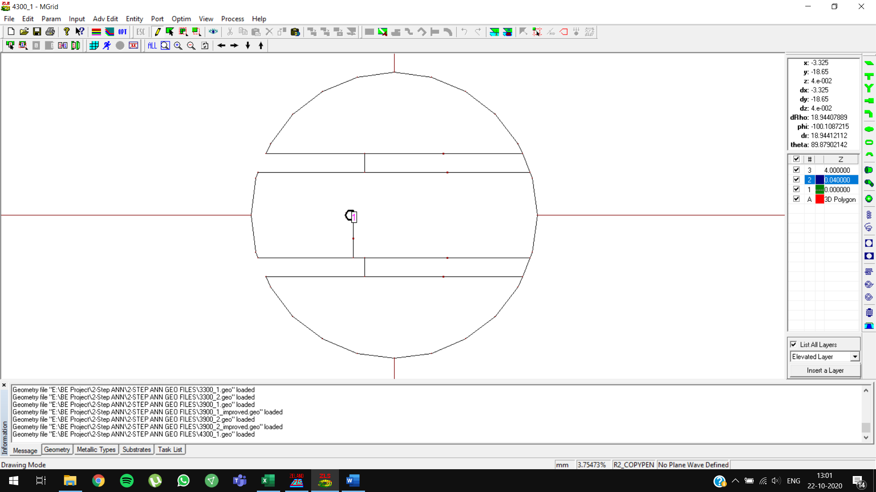

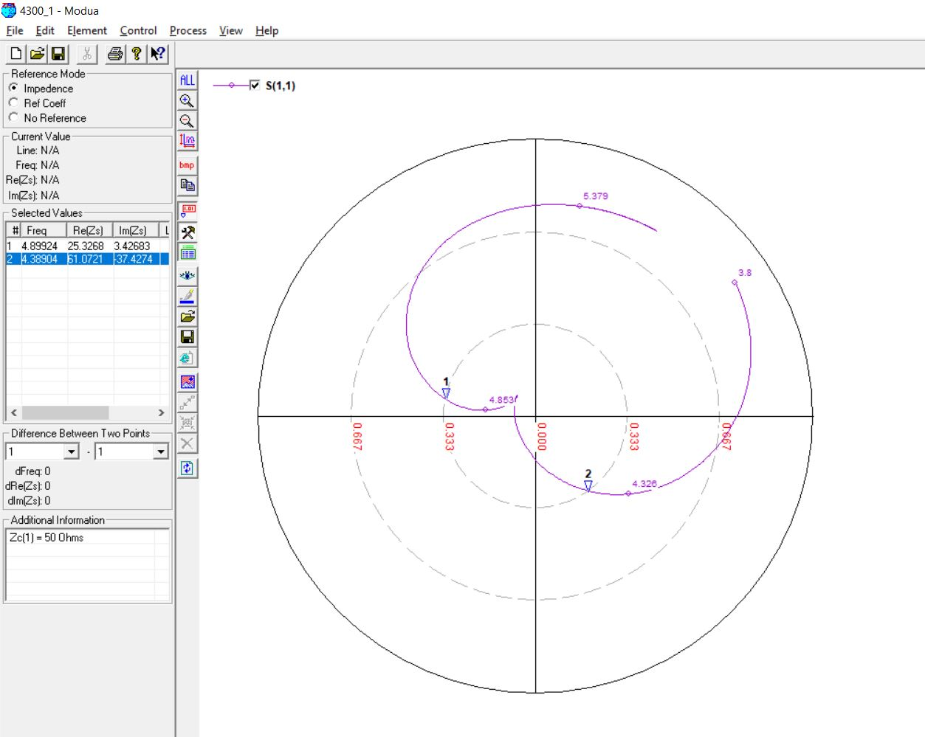

**4300 MHz, 4mm (0.05 lambda) OPTIMIZED**

Initial predictions: slot length = **13.2578 mm**

Optimized predictions: slot length = **13 mm**

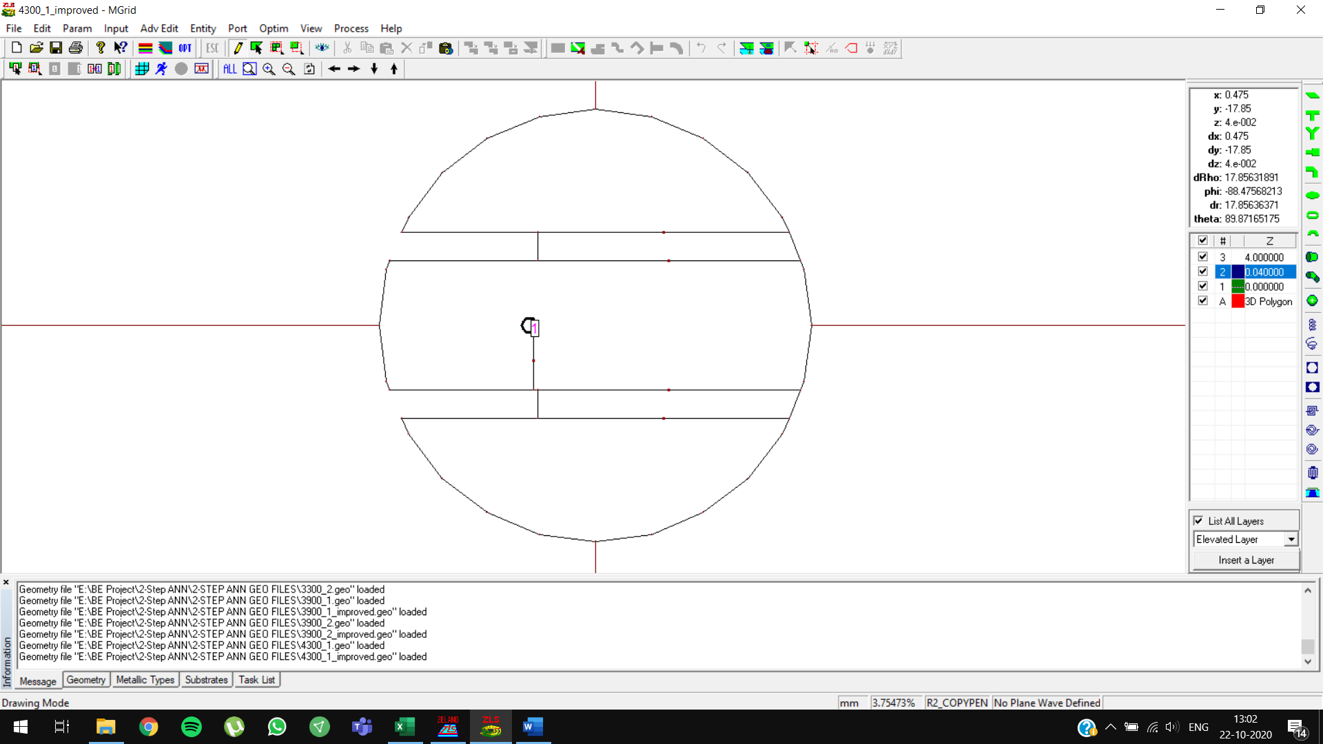

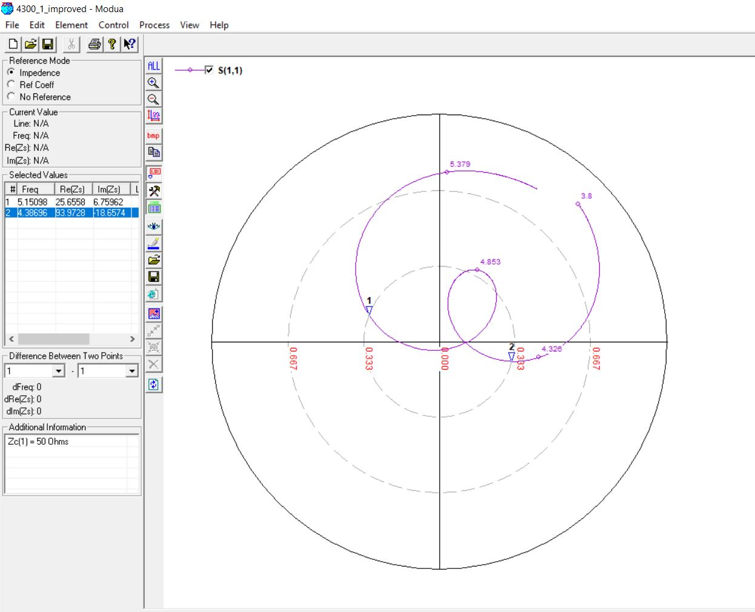

**4300 MHz, 5mm (0.07 lambda)**

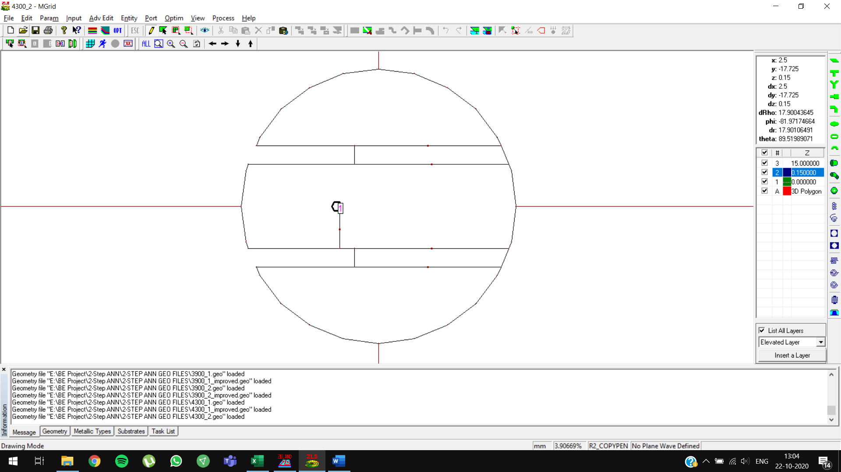

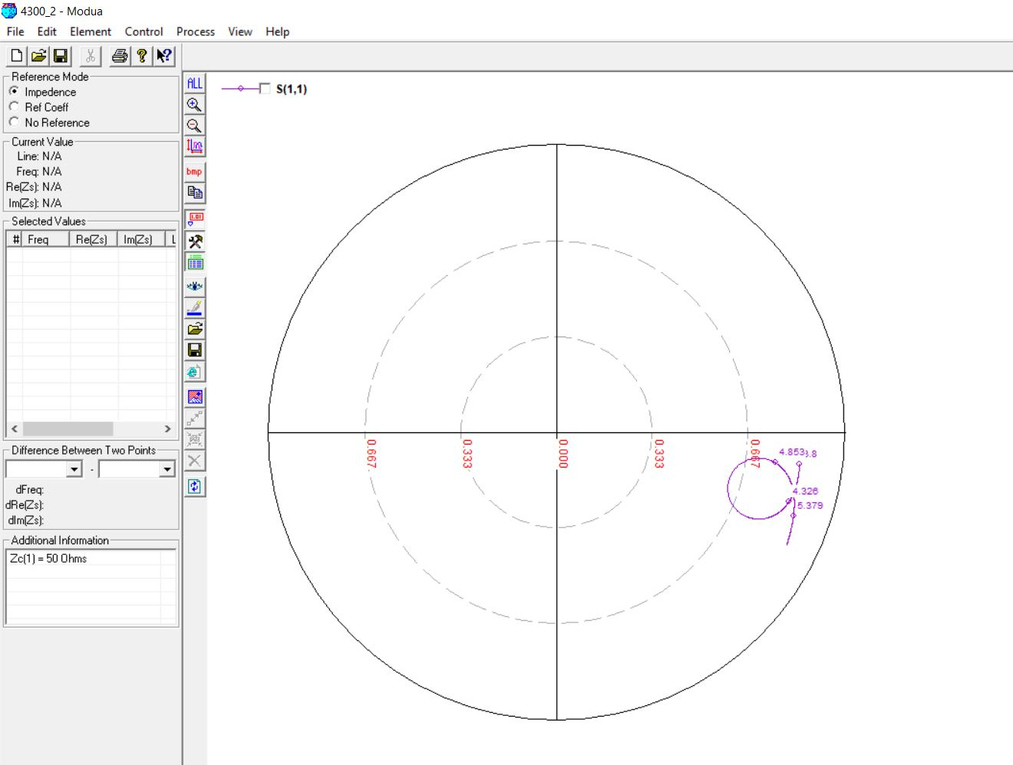

**4900 MHz, 4mm (0.05 lambda)**

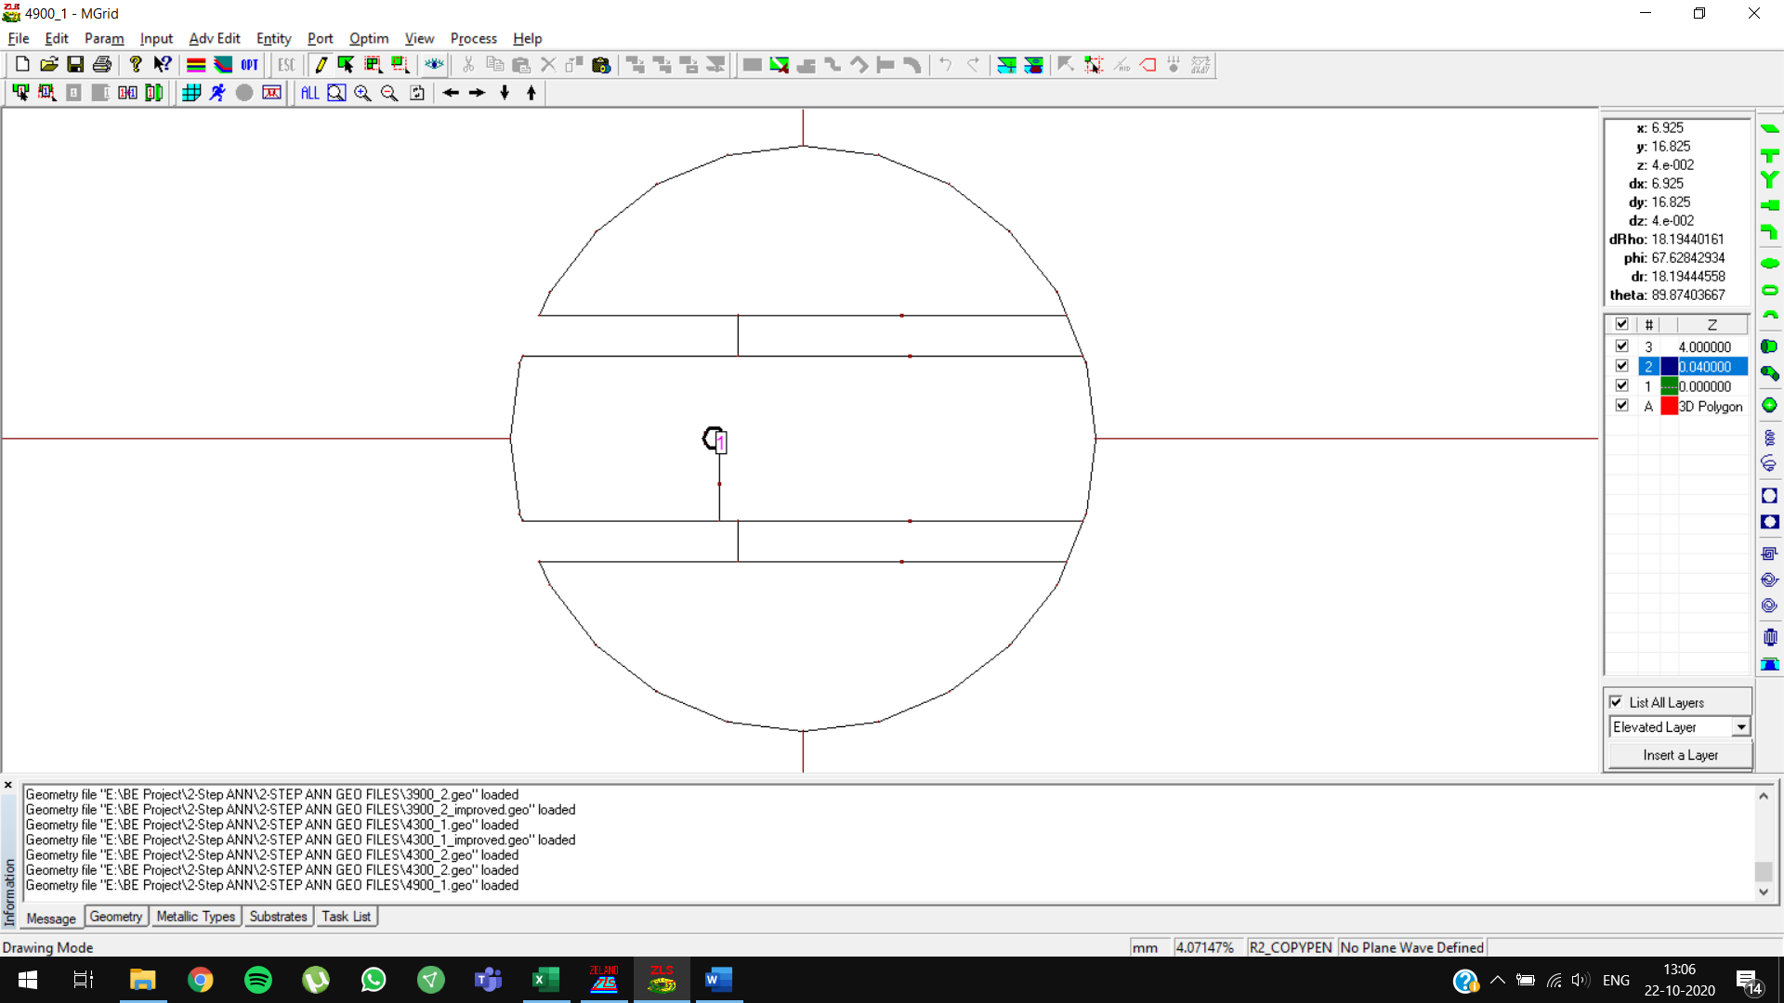

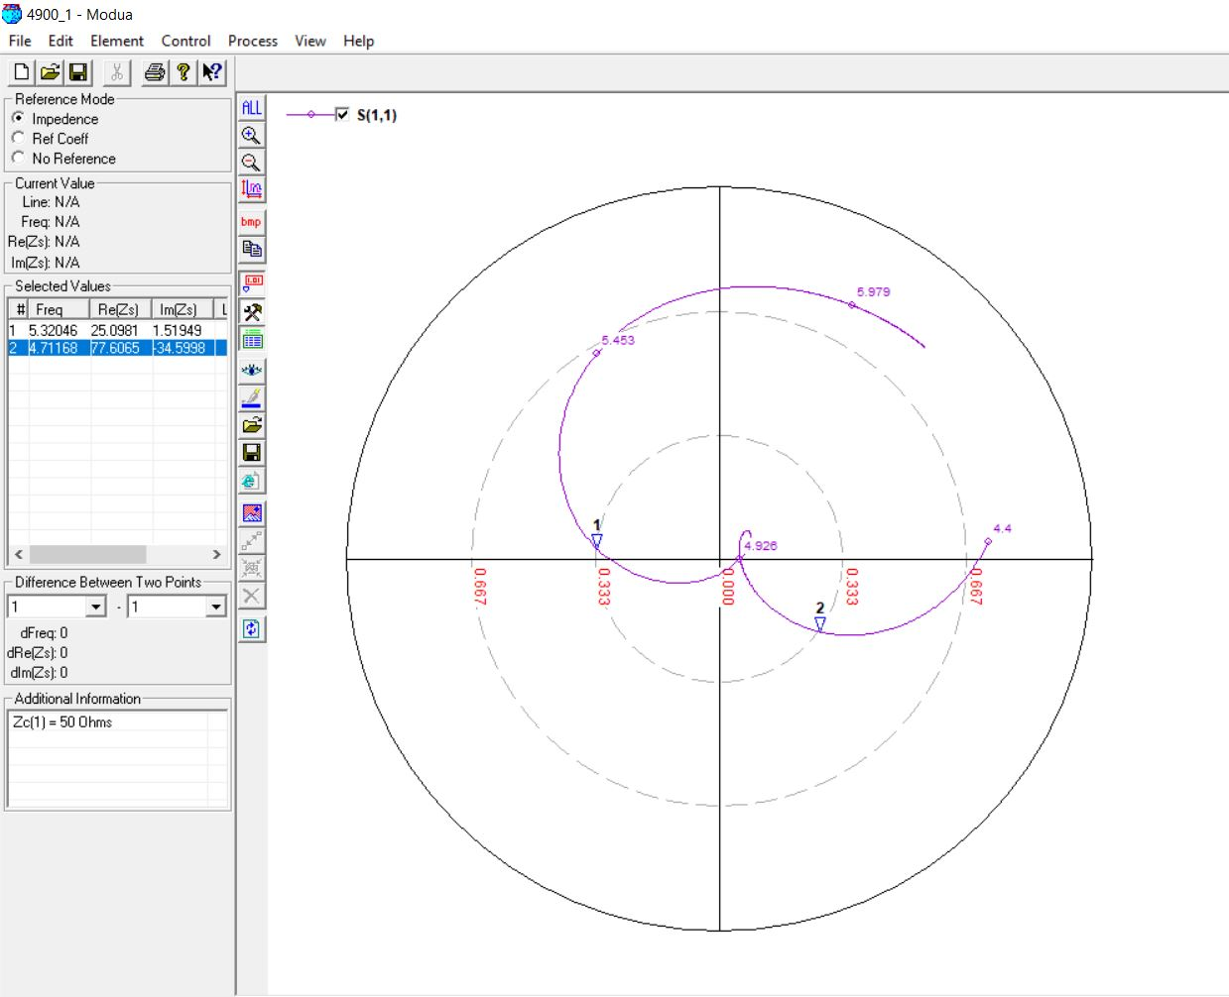

**4900 MHz, 4mm (0.07 lambda)**

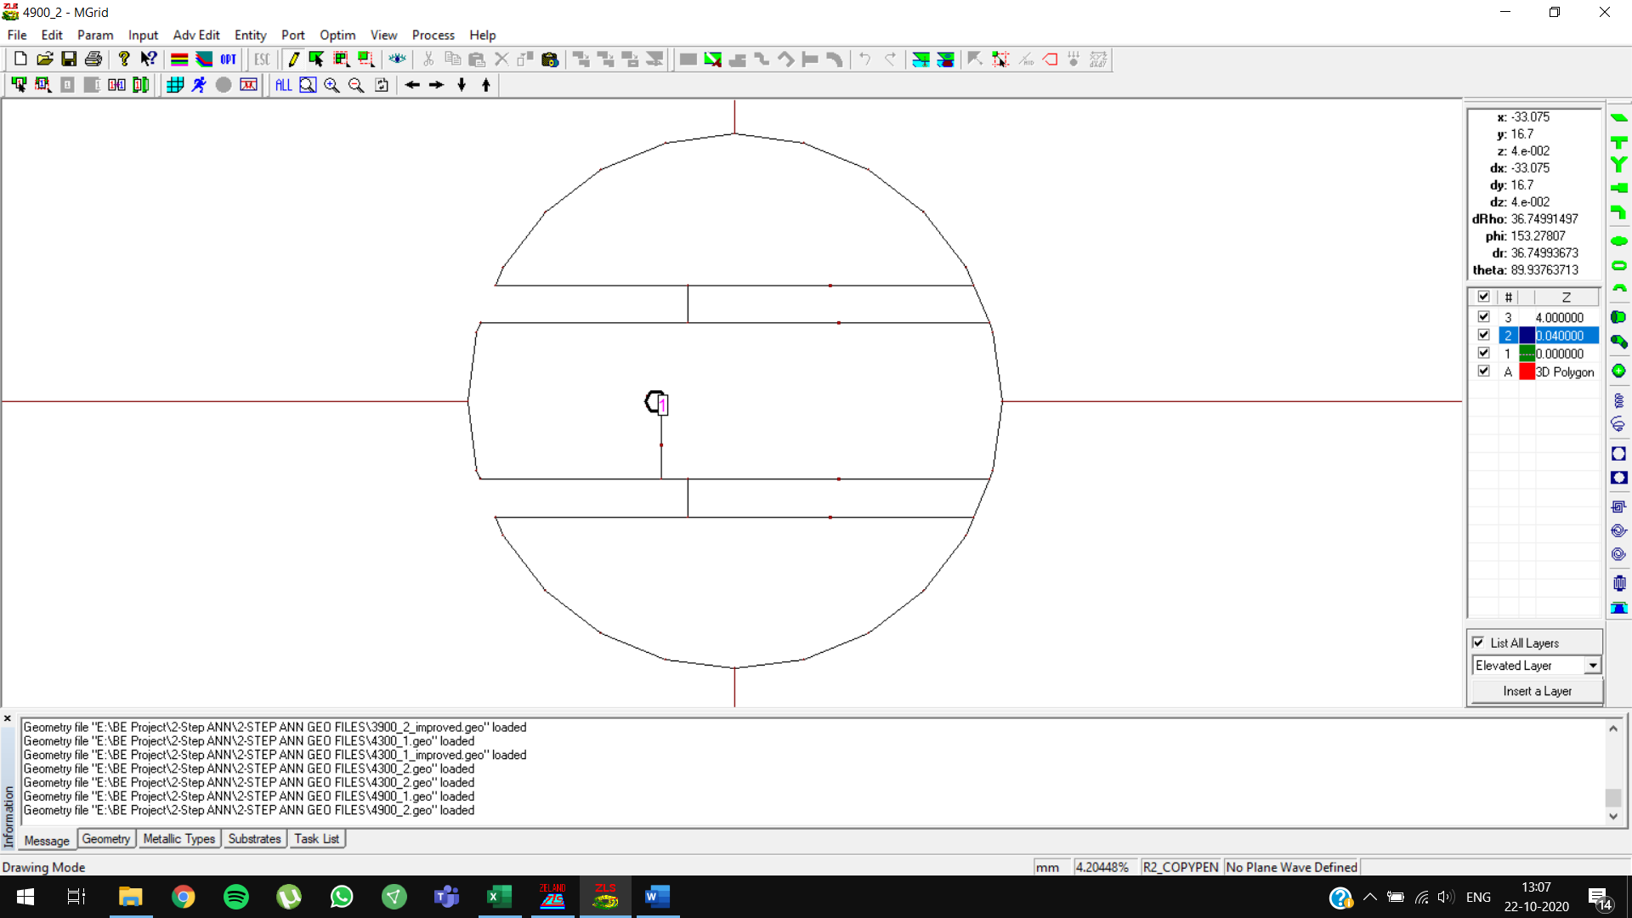

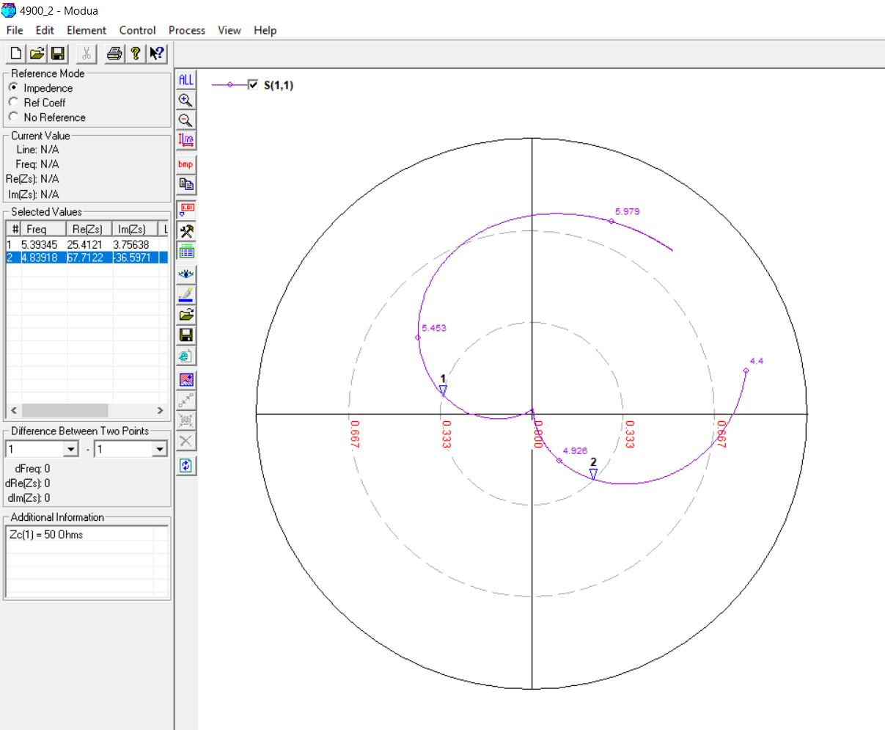

**4900 MHz, 4mm (0.07 lambda) OPTIMIZED**

Initial predictions: slot length = **12.3376 mm**

Optimized predictions: slot length = **12 mm**

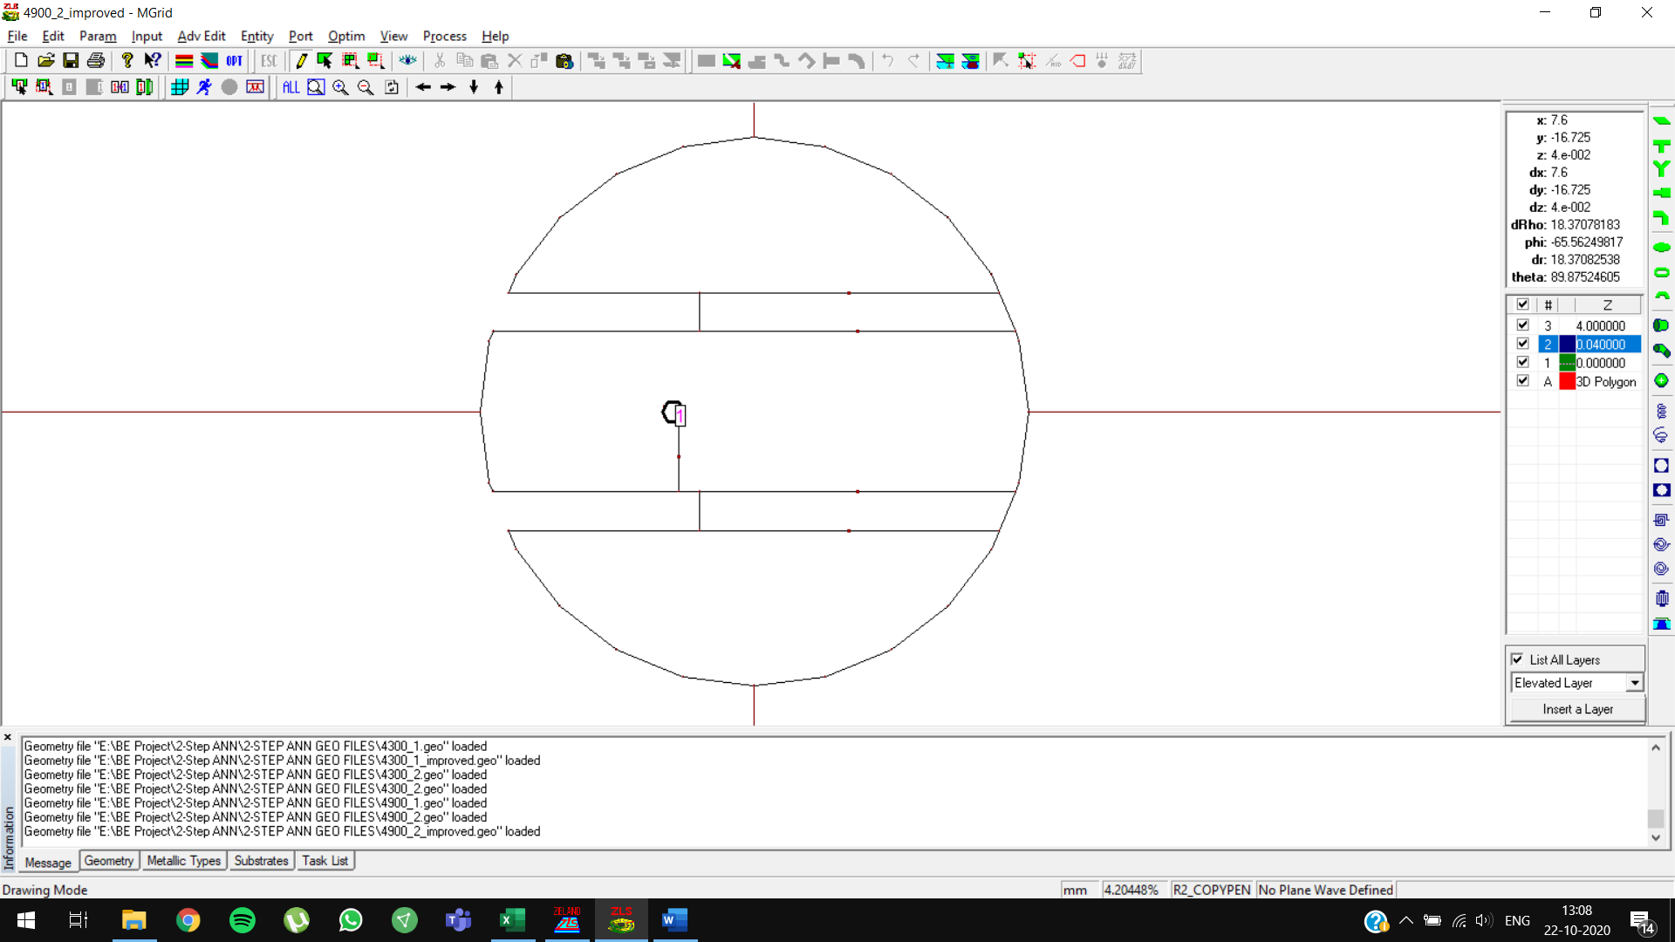

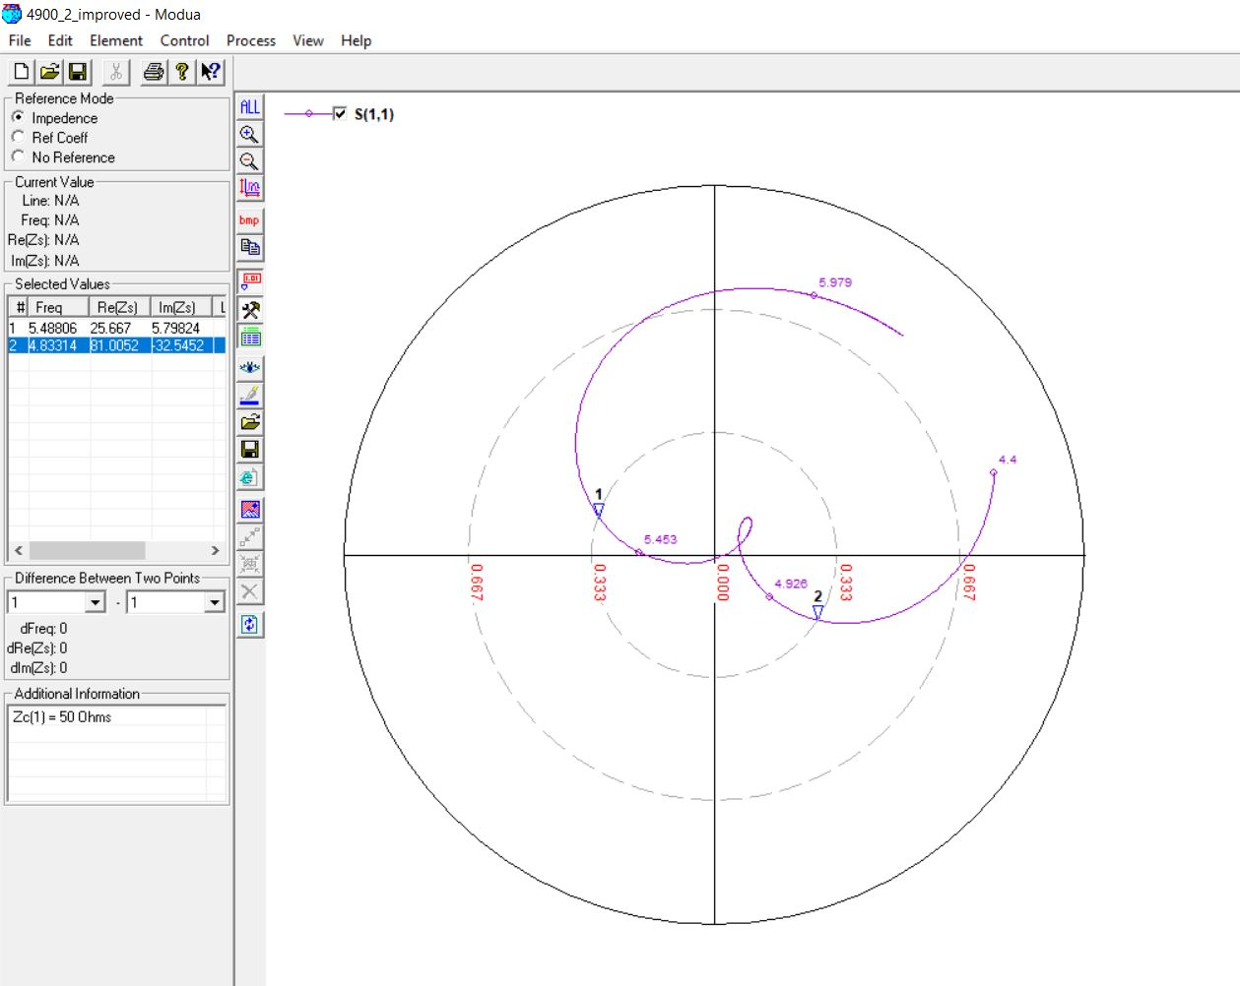

**5100 MHz, 3mm (0.05 lambda)**

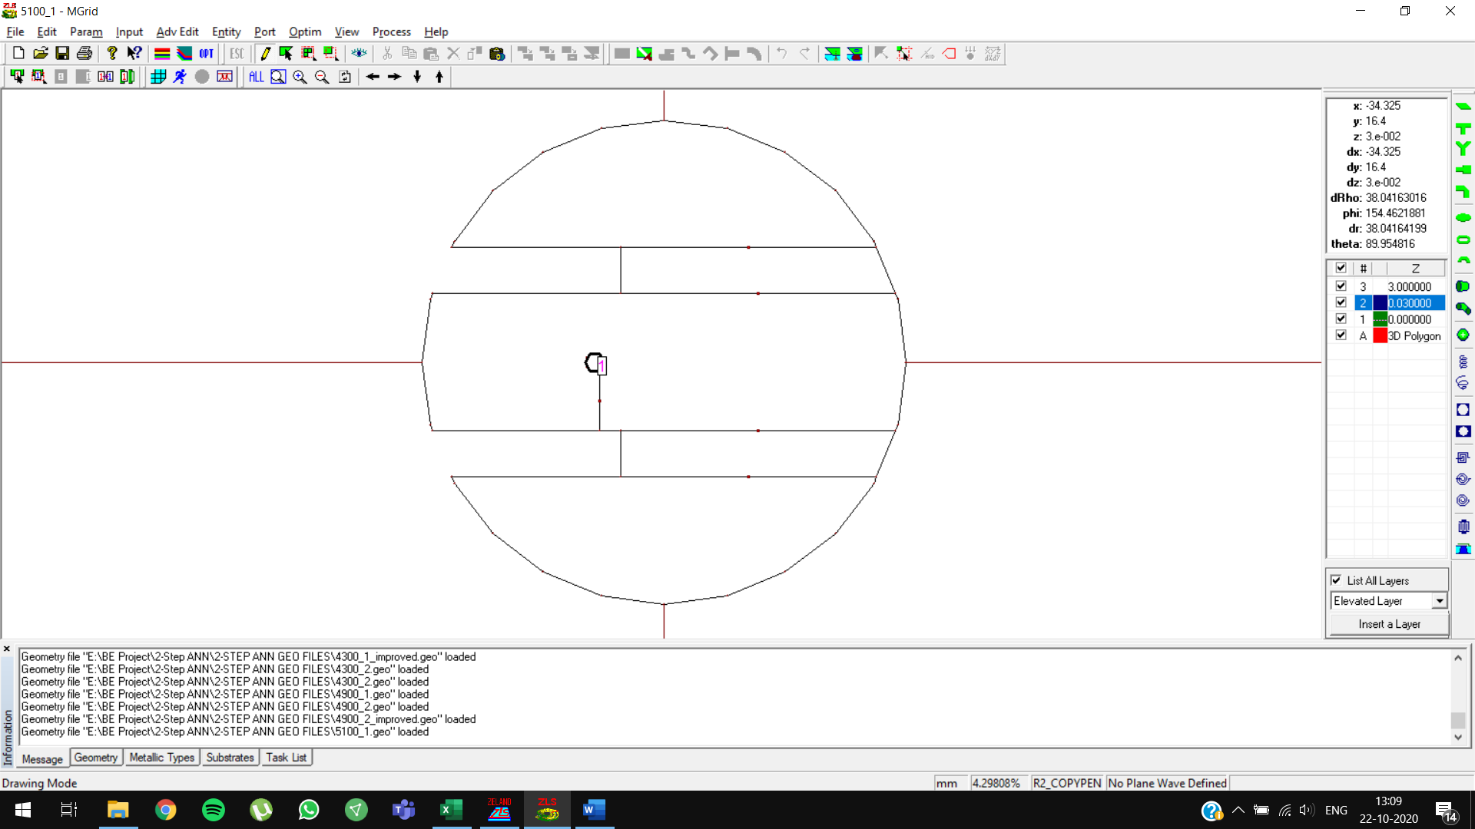

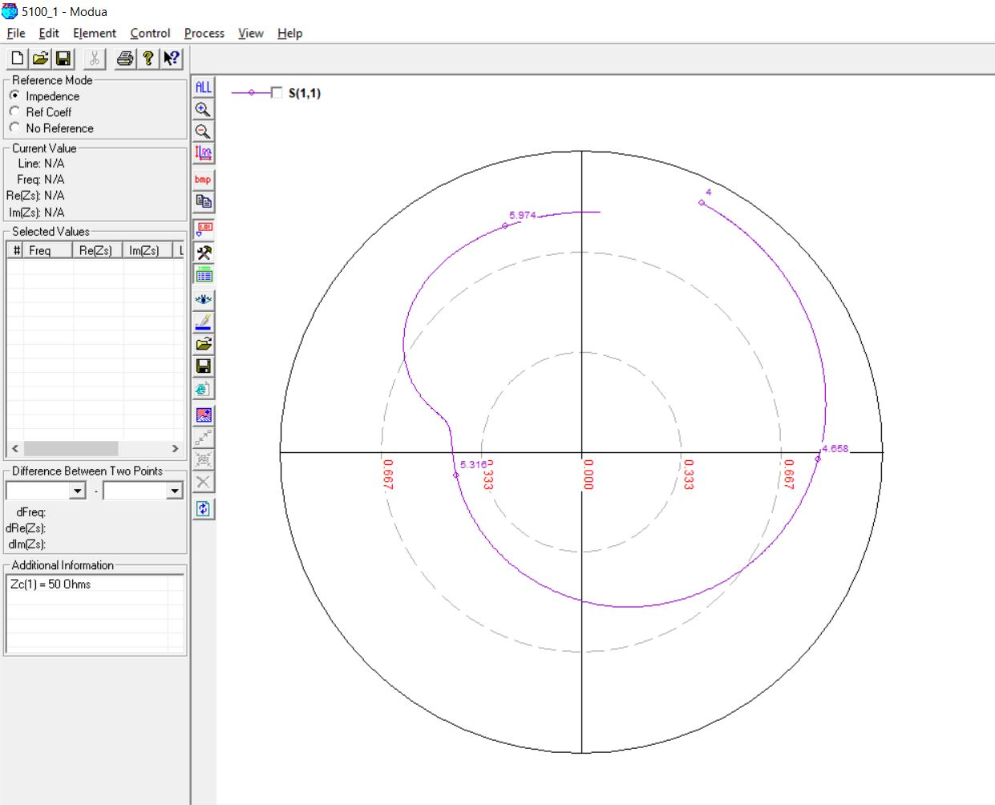

**5100 MHz, 3mm (0.05 lambda) OPTIMIZED**

Initial predictions: slot length = **12.3376 mm**

Optimized predictions: slot length = **11.8 mm**

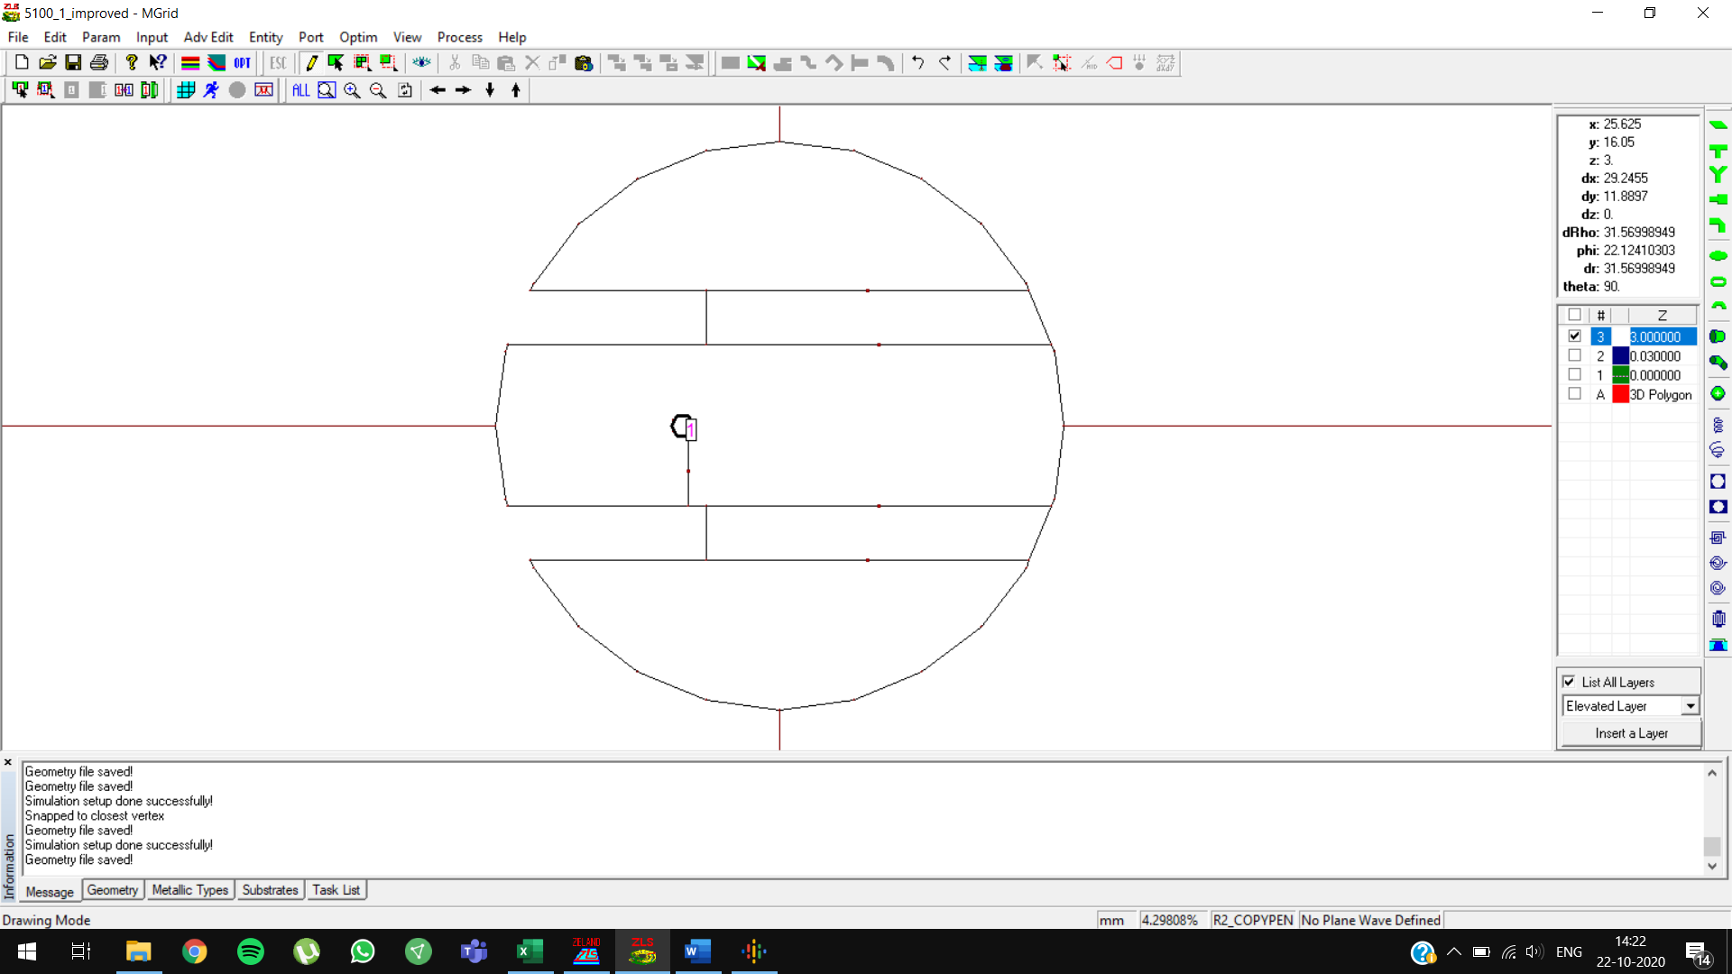

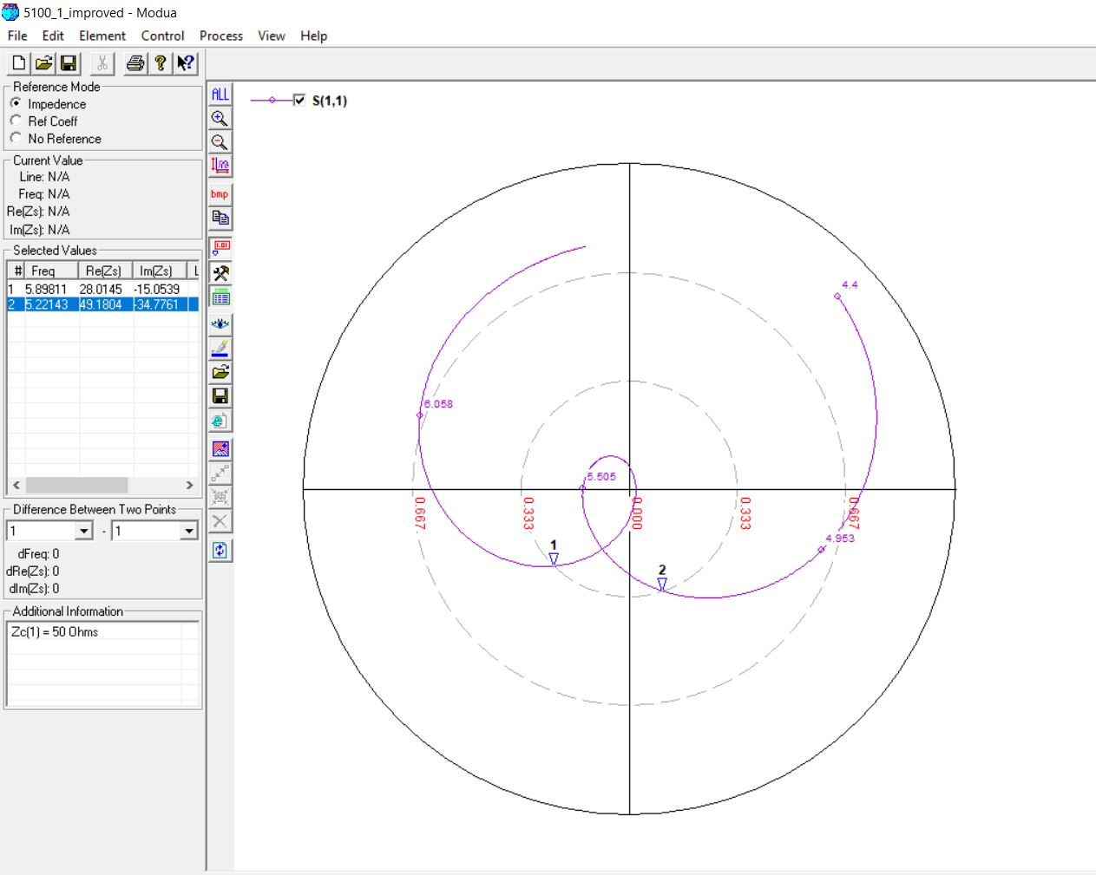

**5100 MHz, 4 mm (0.07 lambda)**

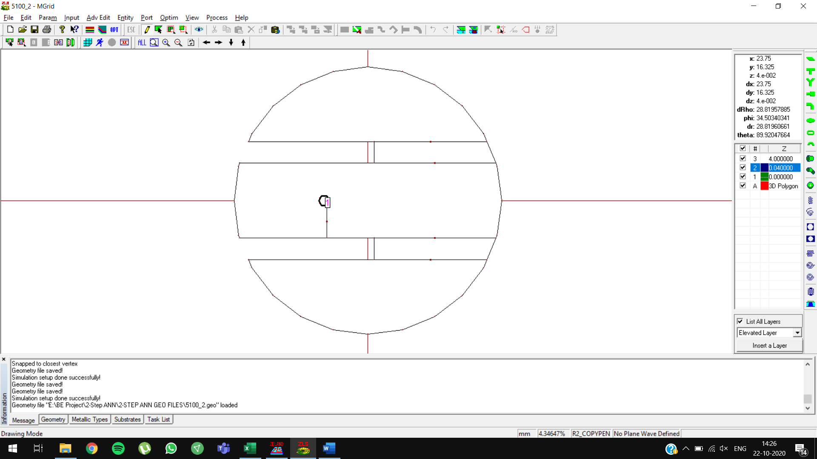

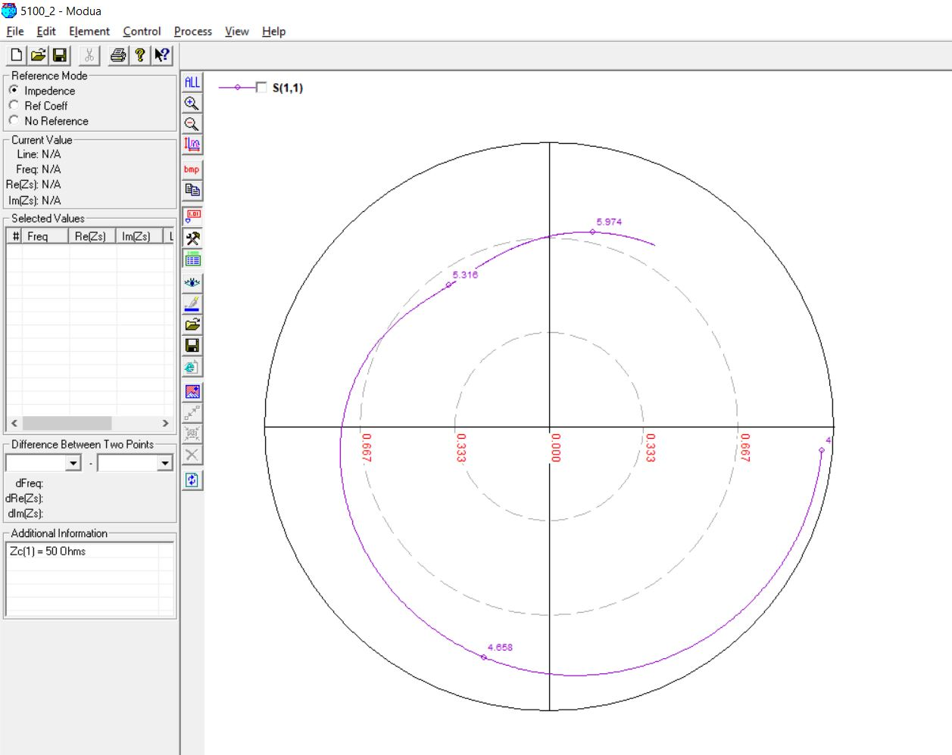

**5500 MHz, 3mm (0.05 lambda)**

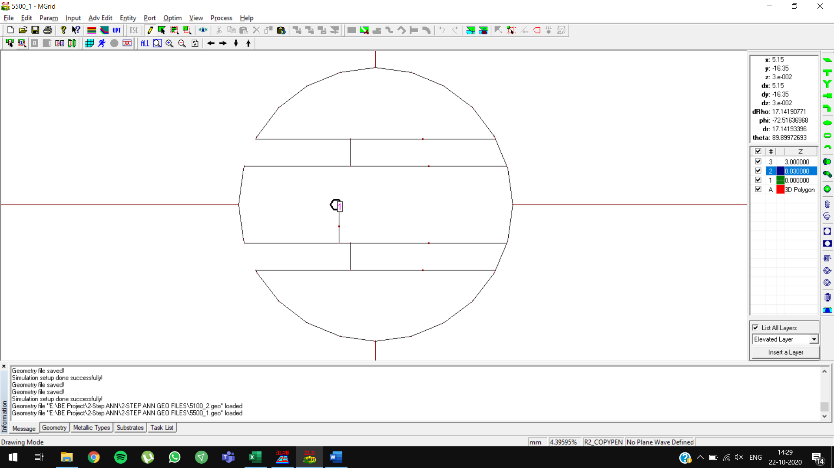

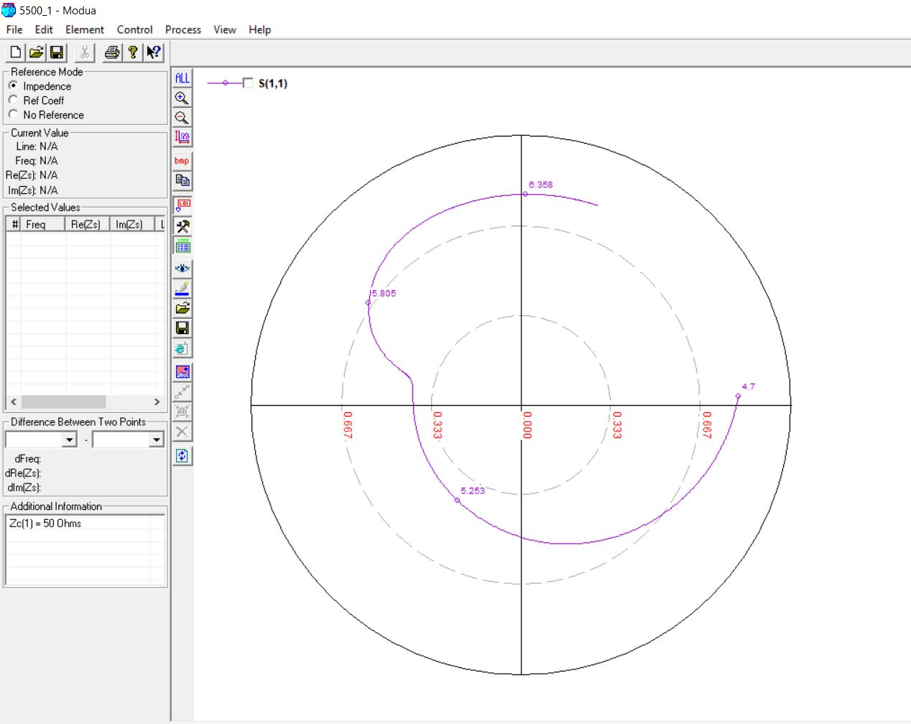

**5500 MHz, 3mm (0.05 lambda) OPTIMIZED**

Initial predictions: feed position = **-4.1205**, slot length = **11.7367 mm**

Optimized predictions: feed position = **-5**, slot length = **10.7367 mm**

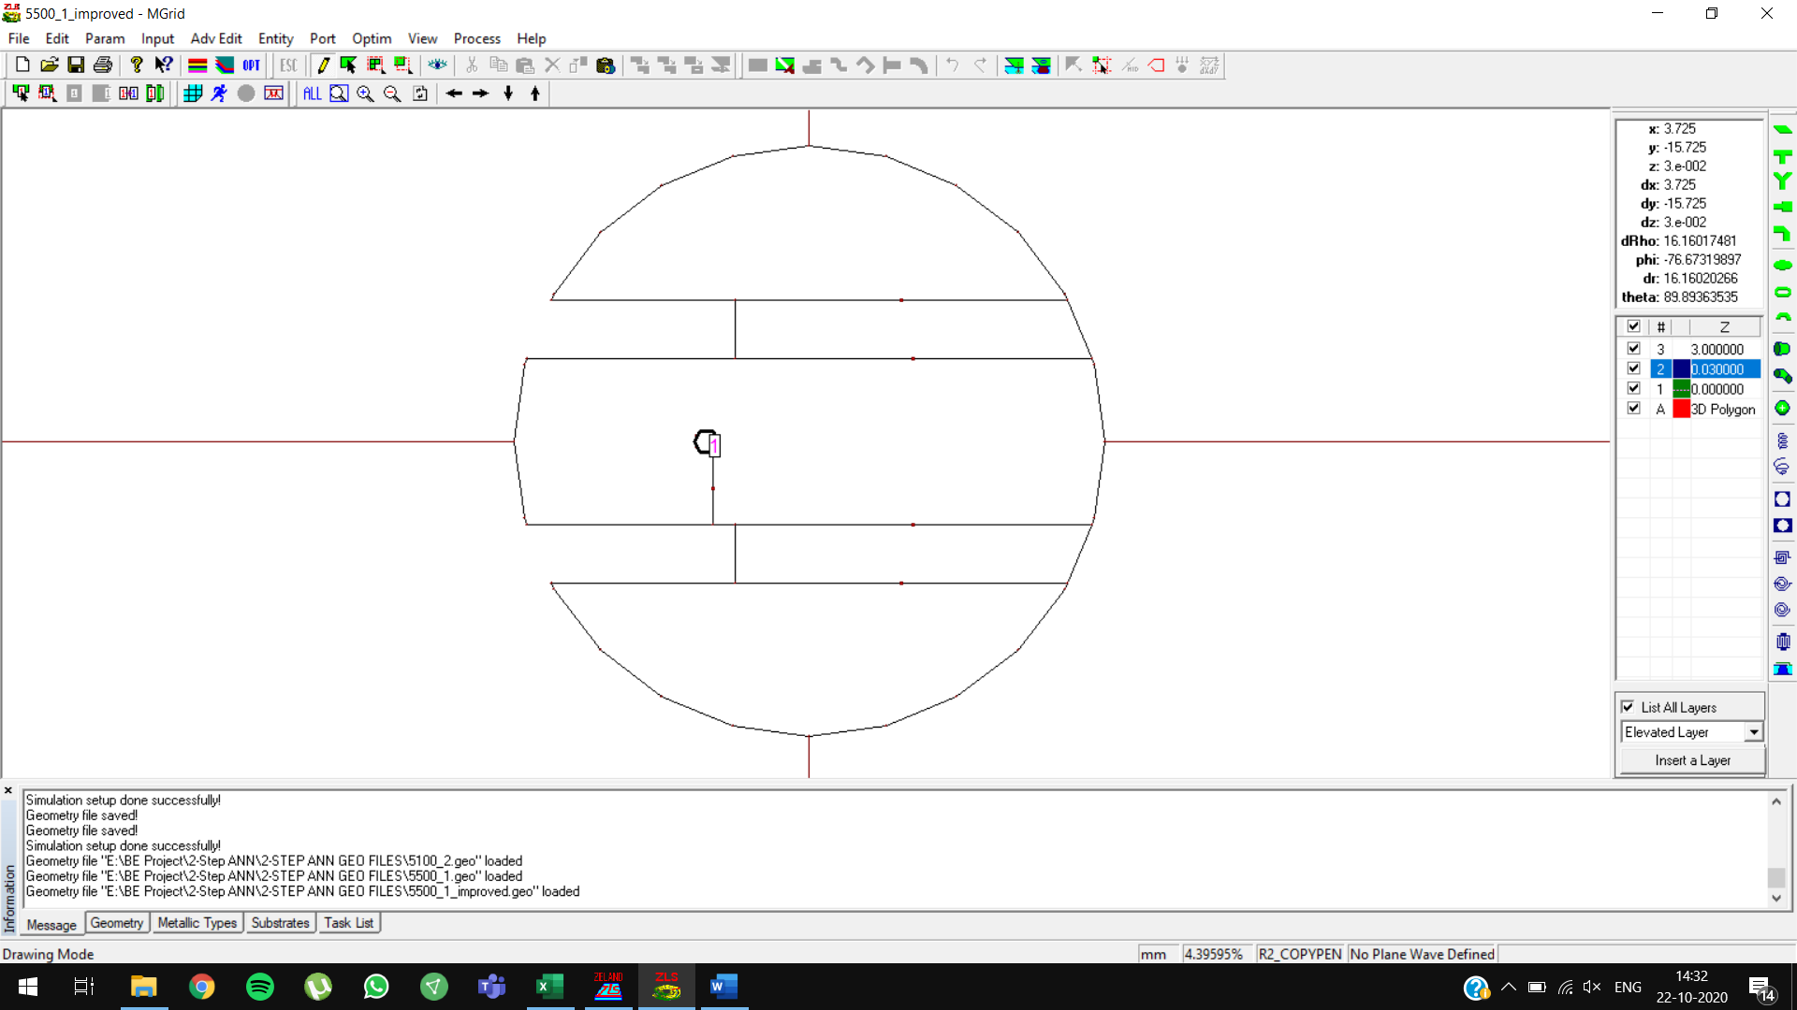

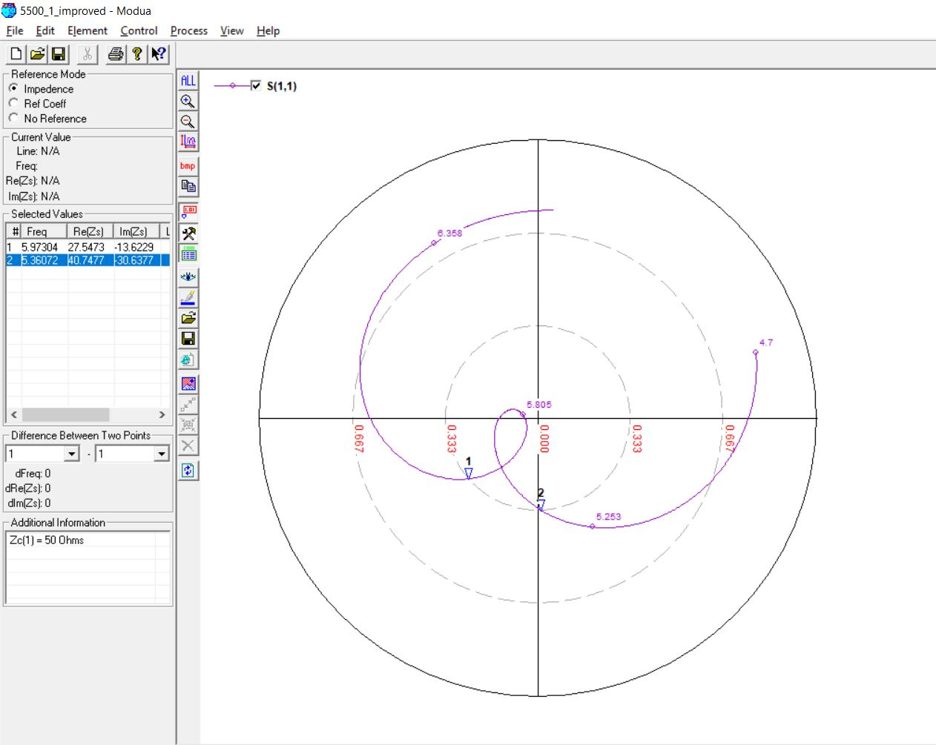

**5500 MHz, 4mm (0.07 lambda)**

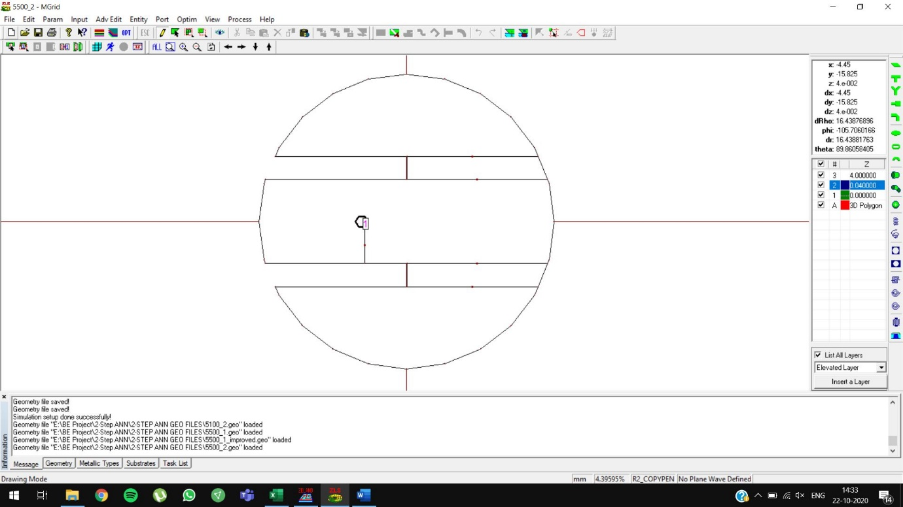

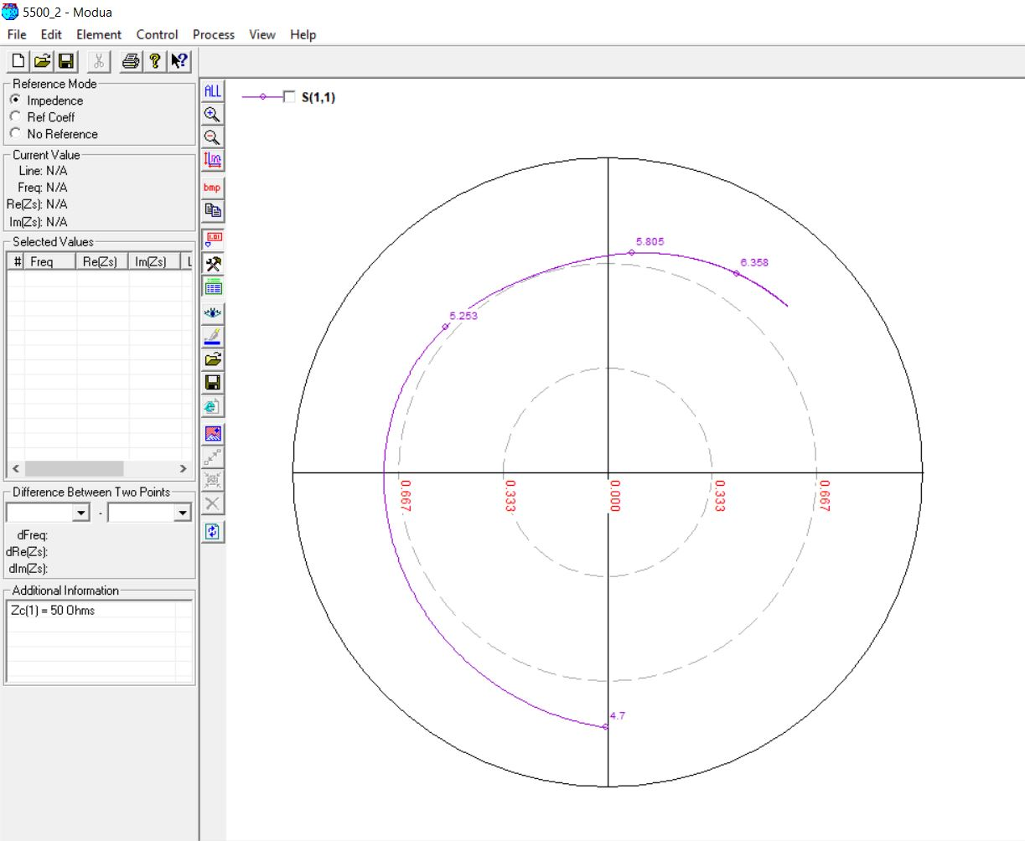

**600 MHz, 27mm (0.05 lambda)**

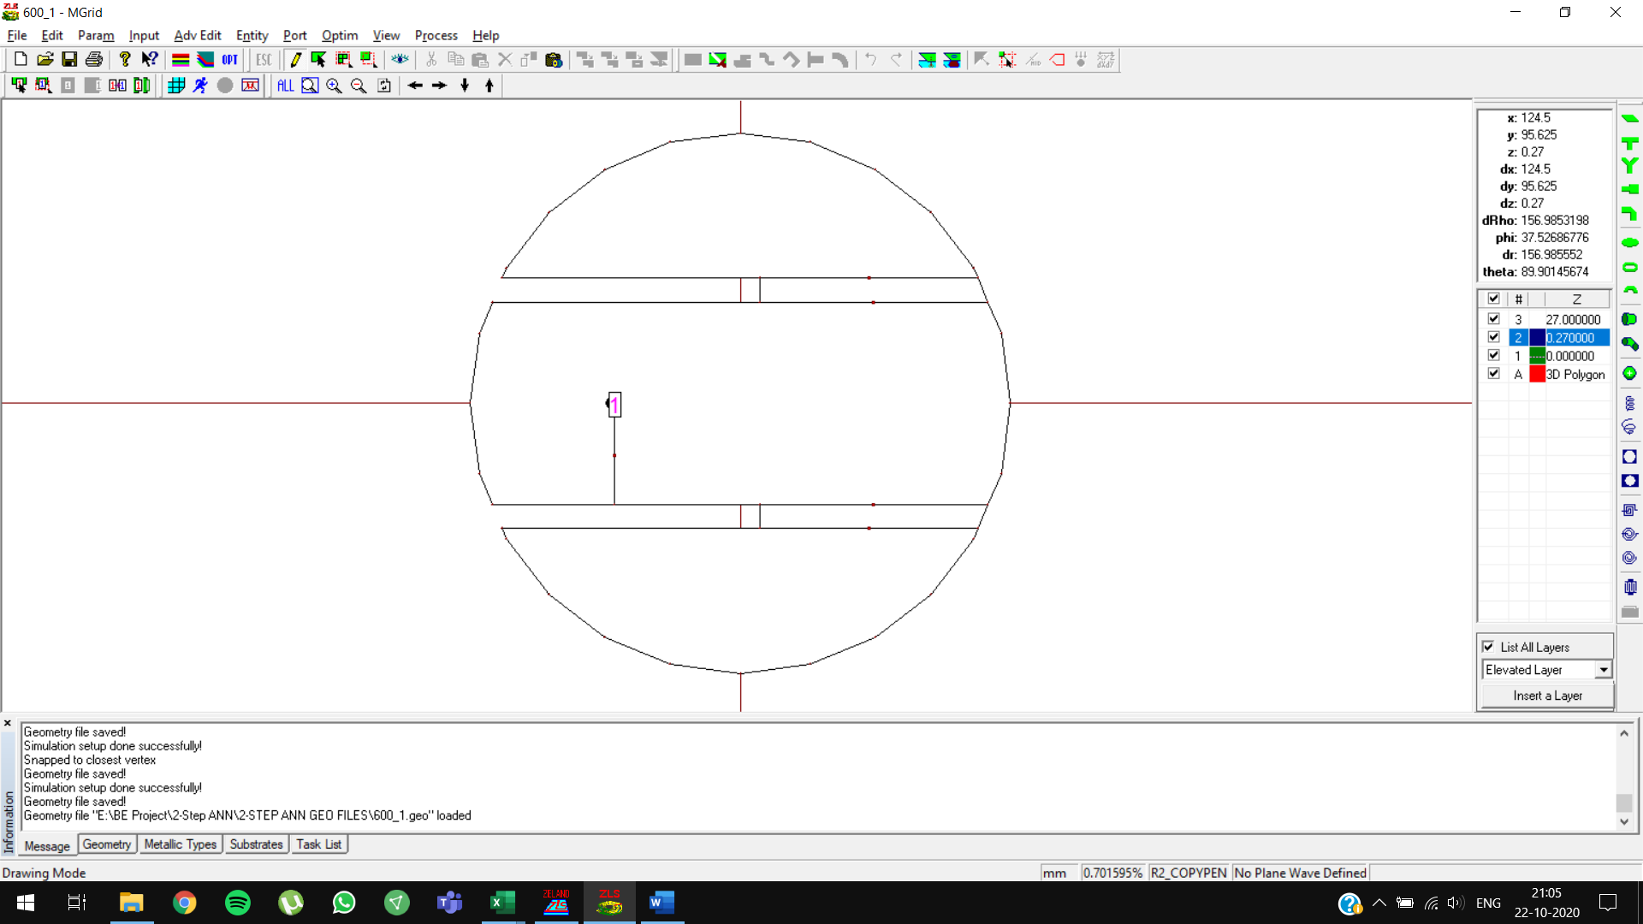

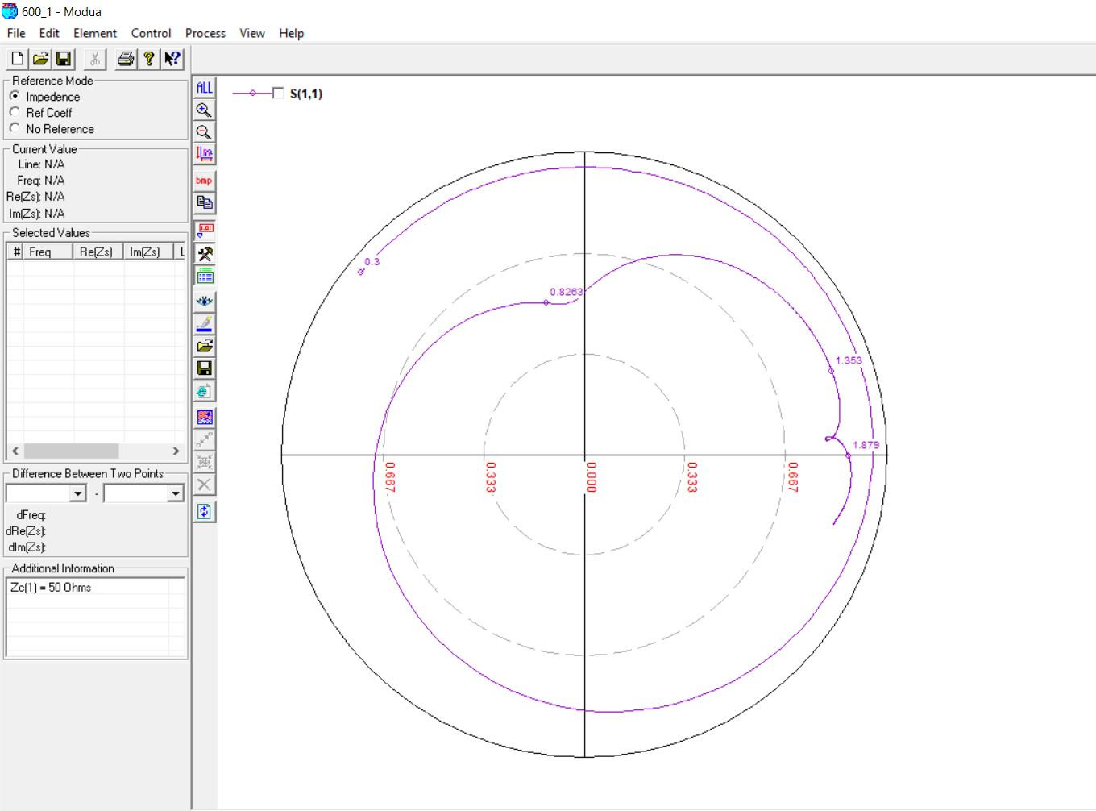

**600 MHz, 28mm (0.07 lambda)**

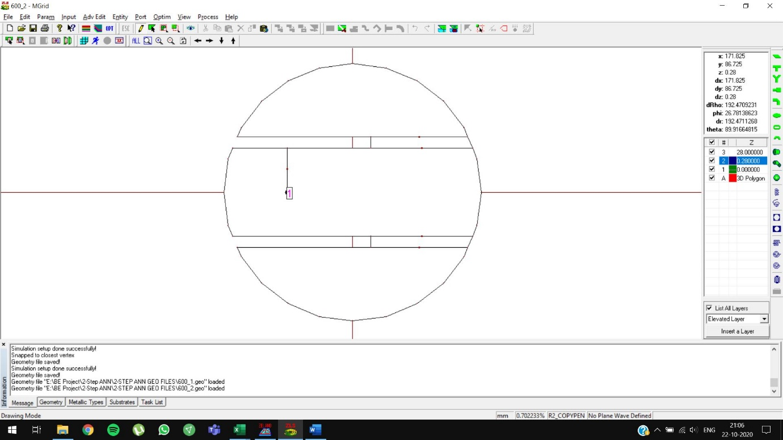

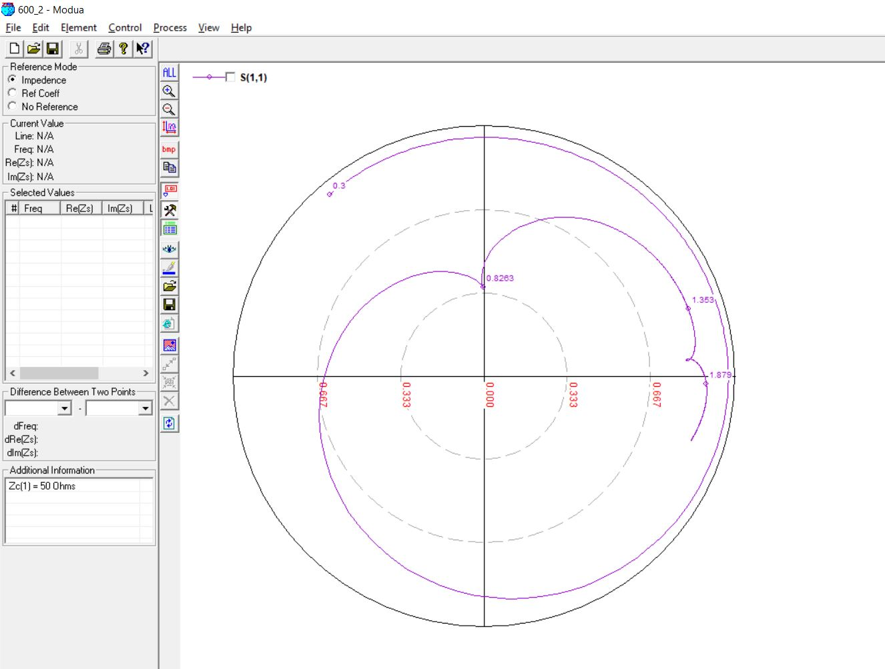

**700 MHz, 20mm (0.05 lambda)**

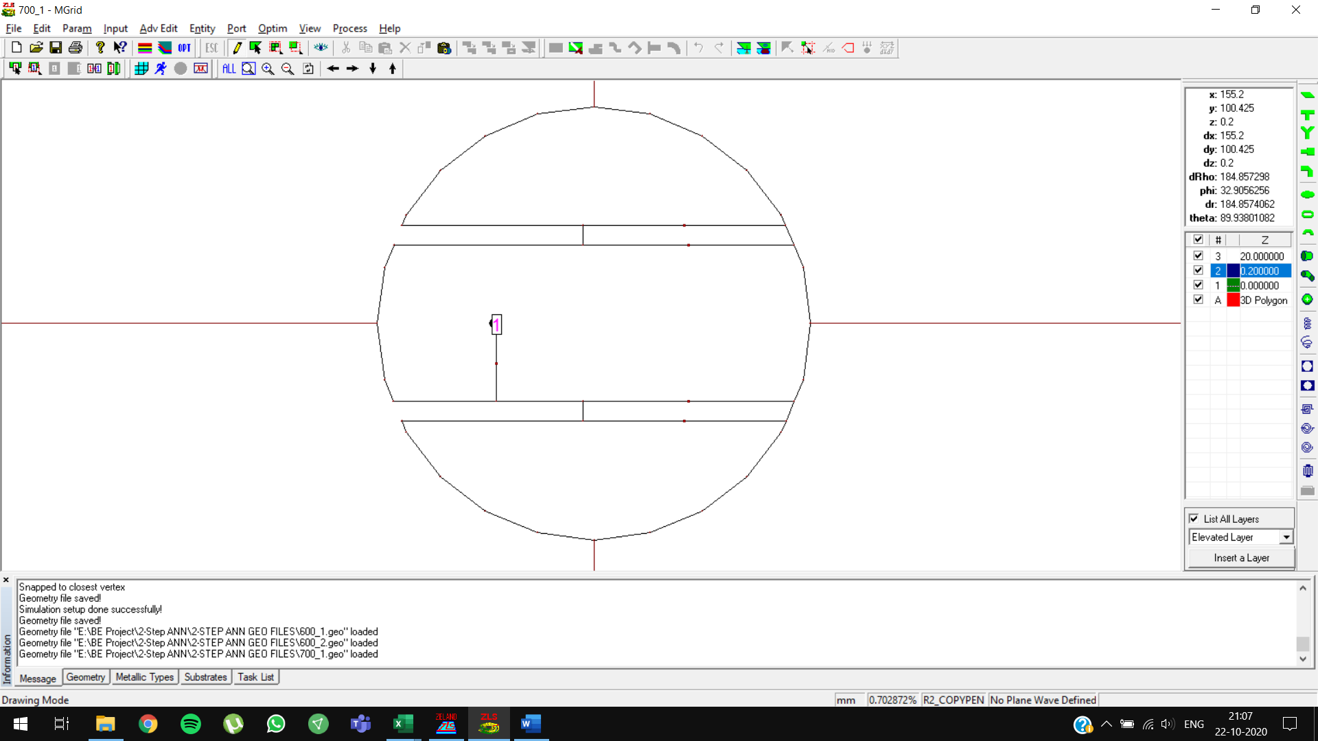

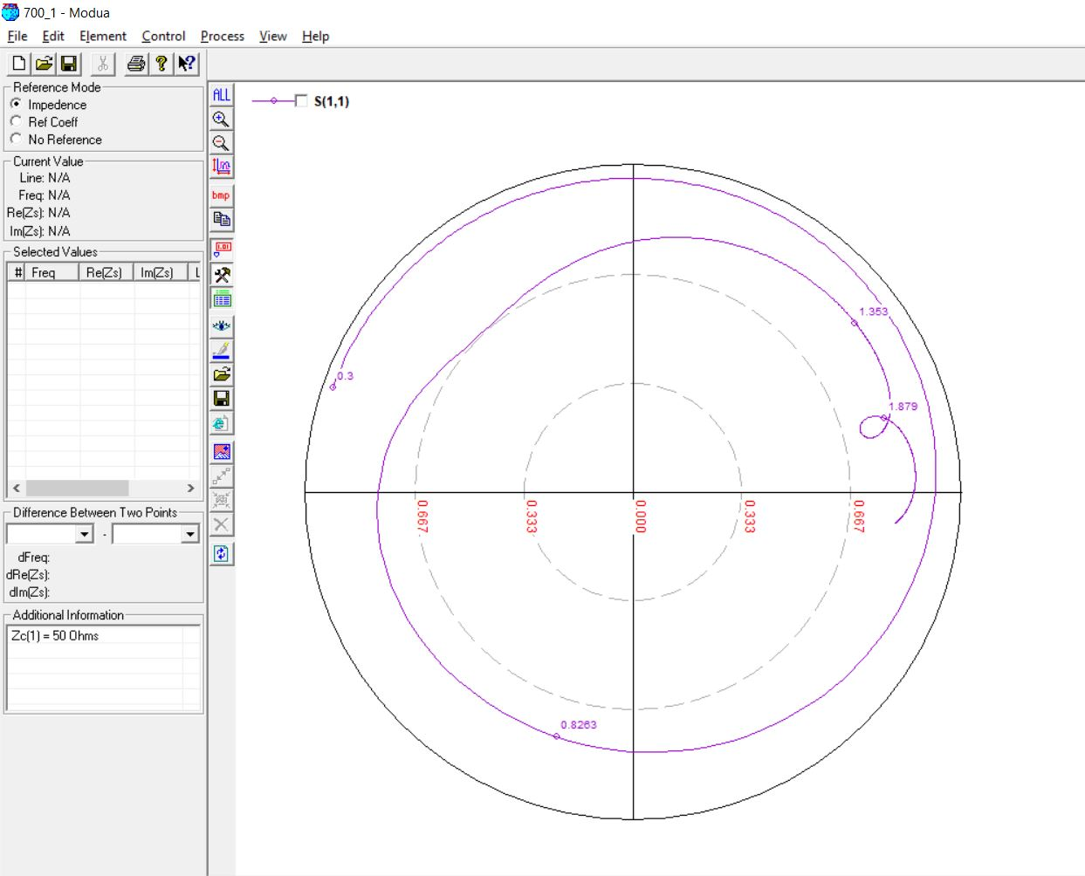

**700 MHz, 27mm (0.07 lambda)**

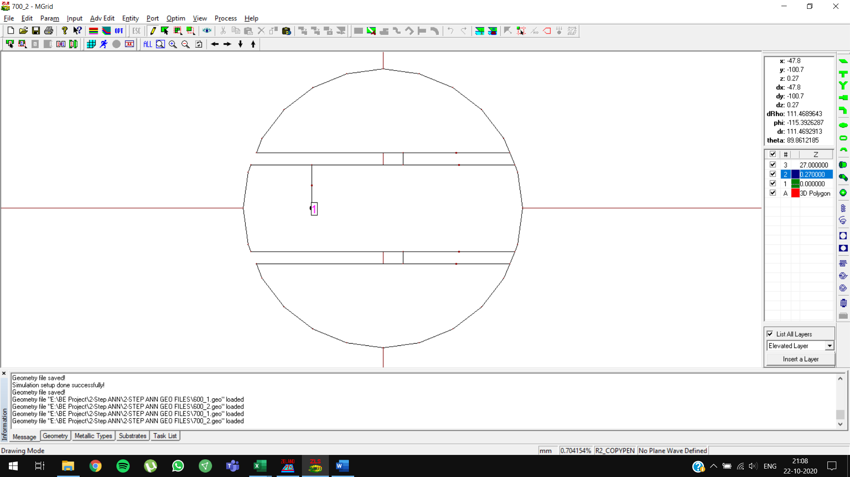

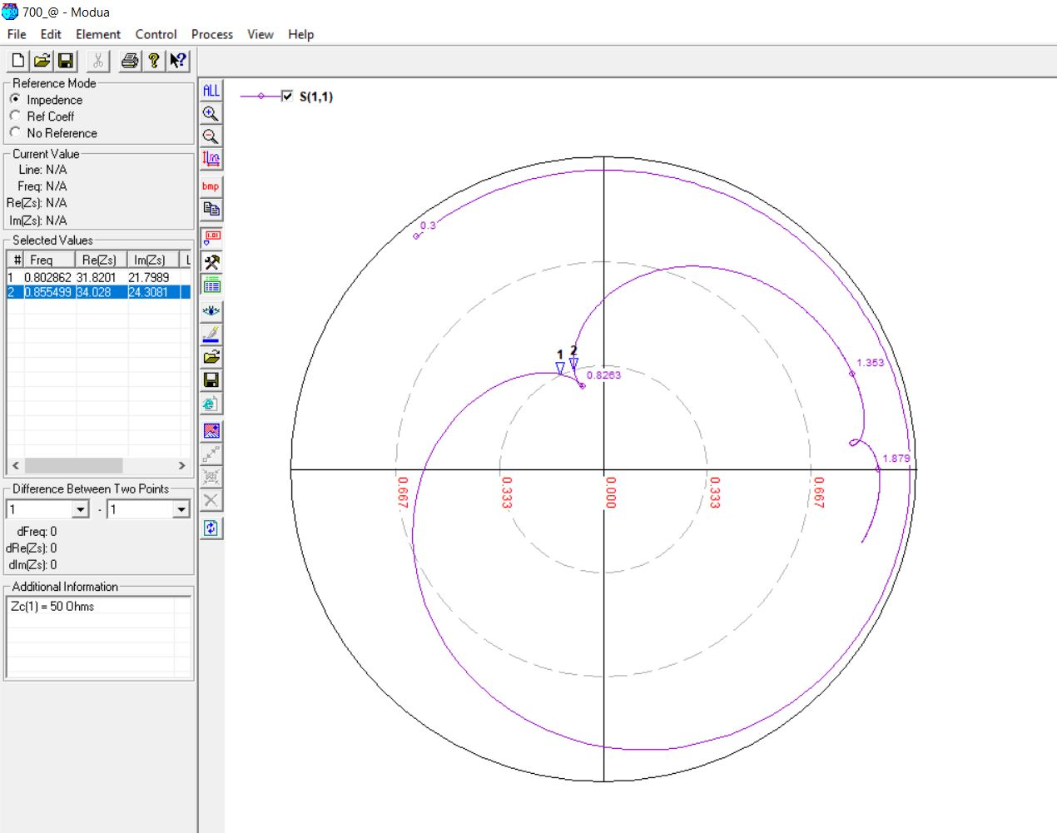

**700 MHz, 27mm (0.07 lambda) OPTIMIZED**

Initial predictions: feed point = **-44.9719**

Optimized predictions: feed point = **-50**

